Rest API

Zawartość

Indroduction 3

Basics 3

Six Constrains of REST 6

Maturity Model 9

Structuring and Implementing the Outer Facing Contract 11

Structure 11

Controller 12

Routing 13

Interaction 14

Implementation of Get 14

Get single resource 16

Status Code 17

Return a status code 18

Formatters and Content Negotiation 18

Getting resources 20

Dto 20

IActionResult<T> 21

AutoMapper 21

Using AutoMapper 22

Parent child route 23

Get a single child 25

Handling a faults 26

Head Http method 27

Filtering and Sorting 28

Passing data to the API 28

Filtering 28

Search 29

One method to rule them all 29

Creating resources 32

Idempotency 32

Post first object 32

Create a child object 34

Create a Parent and Child 35

Creating a list of objects 36

Deal with location of objects list 37

Post to specific resource 40

Options 41

Validate Data and Errors 42

Introduction 42

Input validation 43

Custom Class Validation 44

Validation Attributes 45

Error messages 46

Update Resources 47

Description 47

Update Resource 47

Input Validation 50

Update Collection of Objects 52

Upserting 52

Partial Update Patch 53

Use Patch 54

Validate Patch 58

Upserting with Patch 59

Validate Input in Patch 60

Delete Resources 61

Make an Action 61

Delete Parent and Children 62

Delete Collection 62

Http methods reminder 63

# Indroduction

## Basics

RESTful API is a metod to send a data between server and client sides. It can be created with empty project or project which is designed for this type of application.

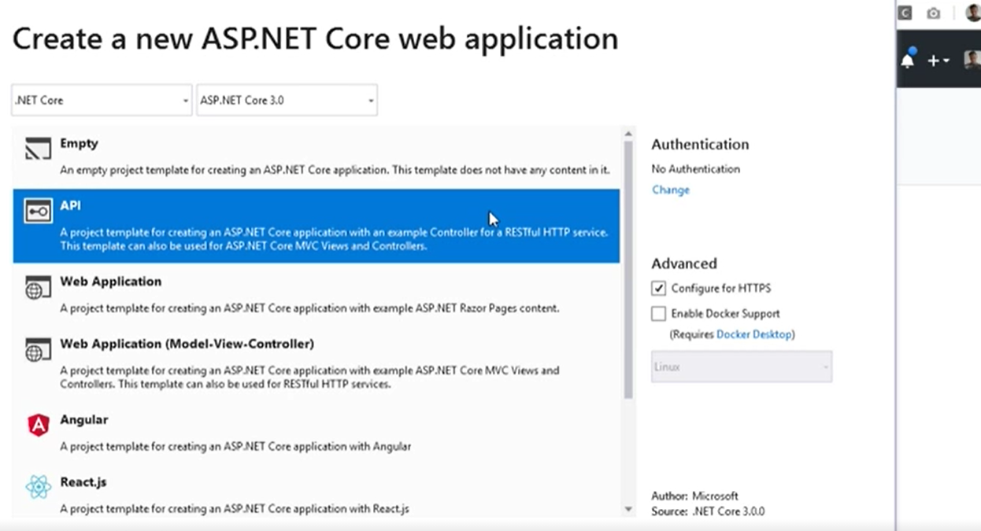

Like always uncheck configure to HTTPS.

Program class is a starting point of our application alike in ASP.NET MVC.

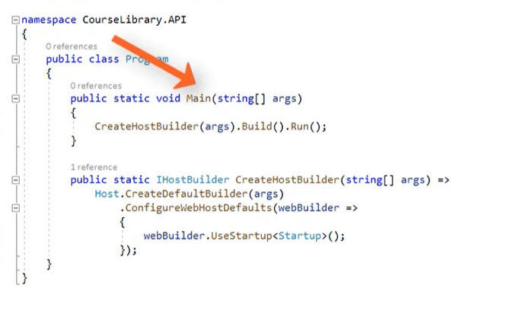

This class above use a Startup class as configuration to set all services and required middlewares.

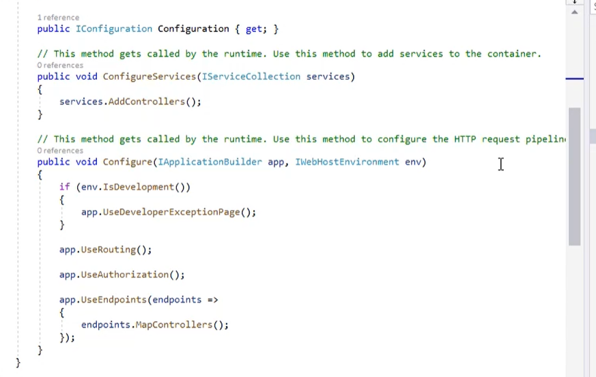

First method is used to add all required configurations and needed object with DI mechanism.

Second one is used to configure a middleware for actions.

In properties in debug bookmark

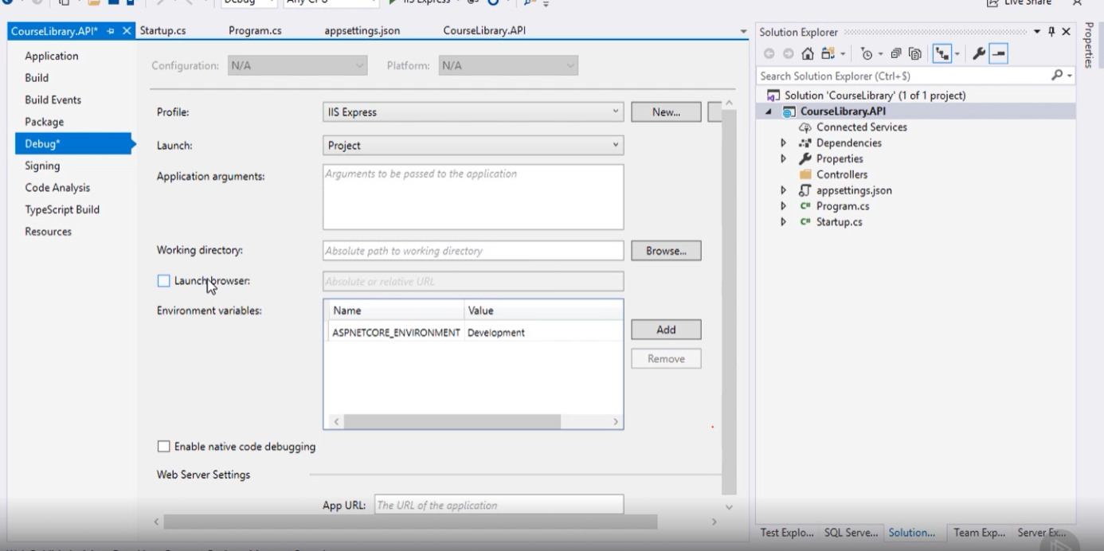

Can be choose launch type it is a IIS(server created by VS 2019) and Project with is preferred to test api. Little under there is a launch browser option uncheck that, because there is no need to open browser with each project start.

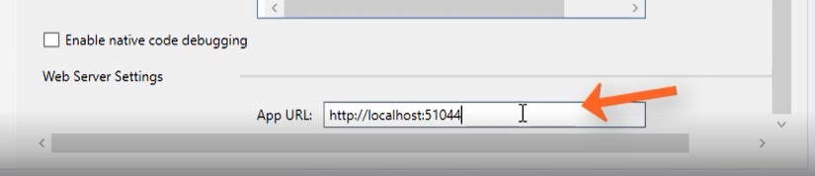

And go little beneath and there is a APP URL it can be changed for you own preferences.

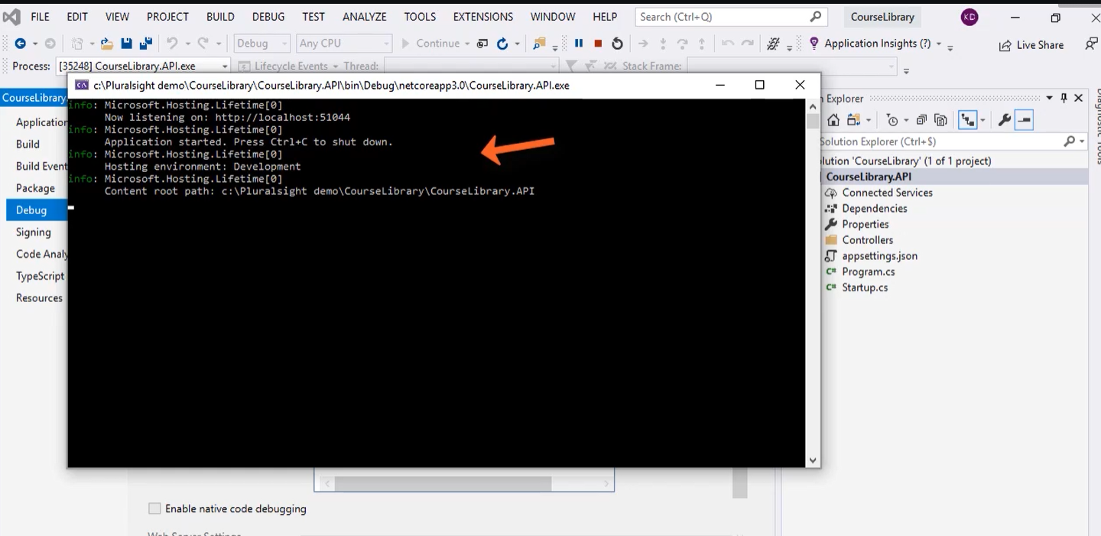

Now when project will be started in console window will be display all these informations.

When all basics configuration is done. Add some data in seed to Db it can be of course in memory provieder.

Then register a class and DbContext with path to server.

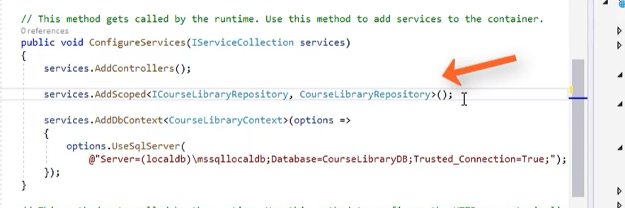

Seed data and add migration which will be established in a DB.

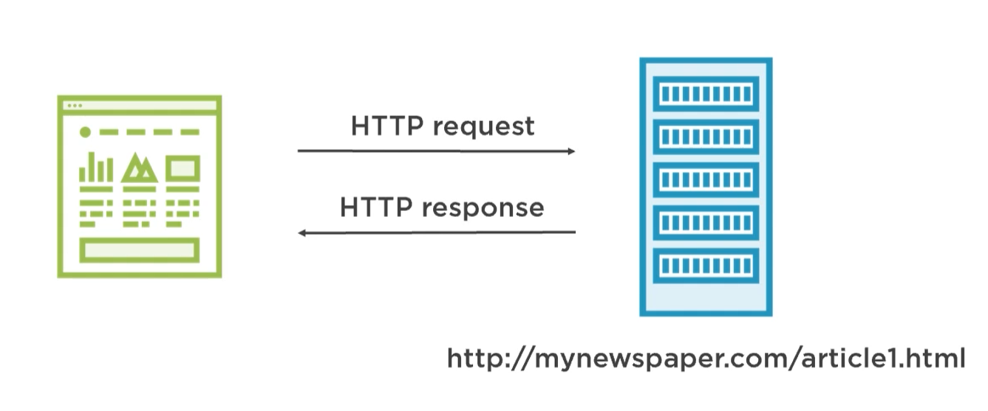

Res is a architectural of sending and retrieving data from client server pair. It works the same way like MVC, client create a request and server send a response.

## Six Constrains of REST

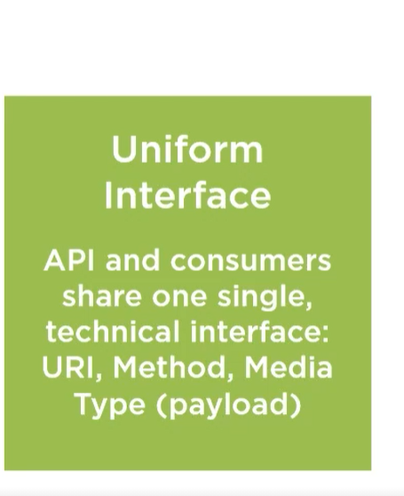

Each API is consumed by use single technic. It means we use HTTP methods and data type like JSON or XML and can be added a payload like header and return status code, it means all set ups is standardized.

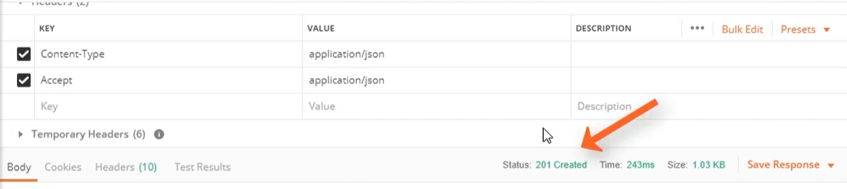

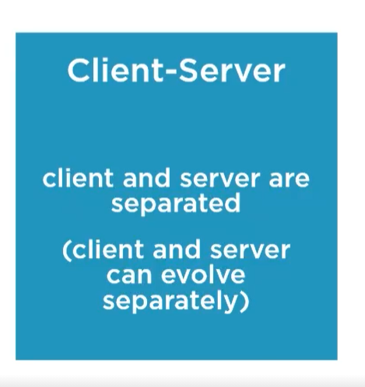

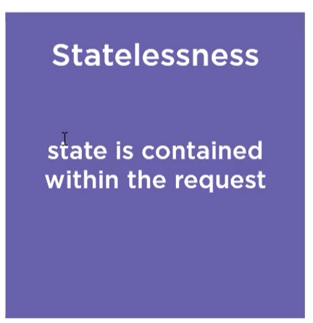

An application doesn’t keep information about object state. All modifiers like header, body, url and http method is enough to manipulate data an make an operation in program.

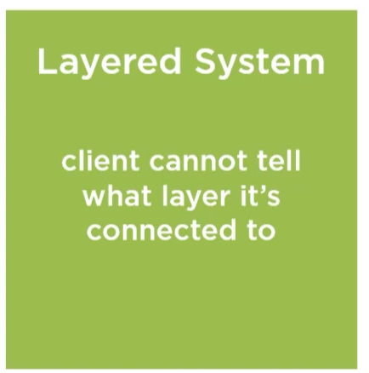

Clean architecture.

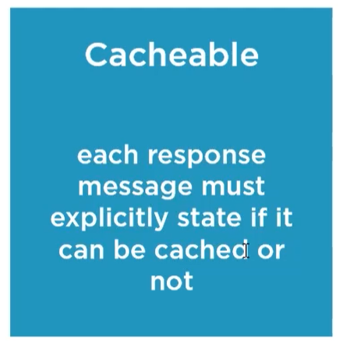

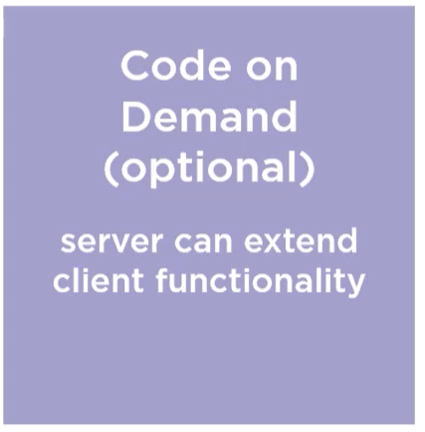

Server can translate a code to client to extend a functionality but it is not secure.

## Maturity Model

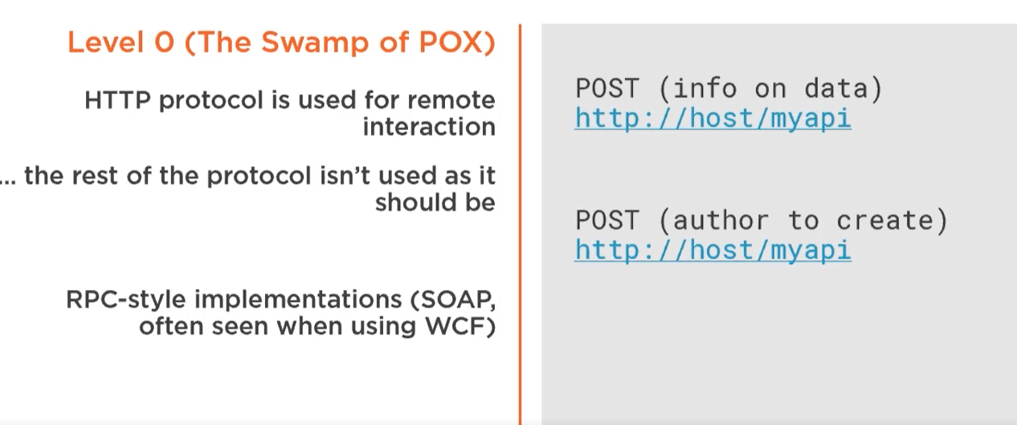

Use a http to communication between client and server.

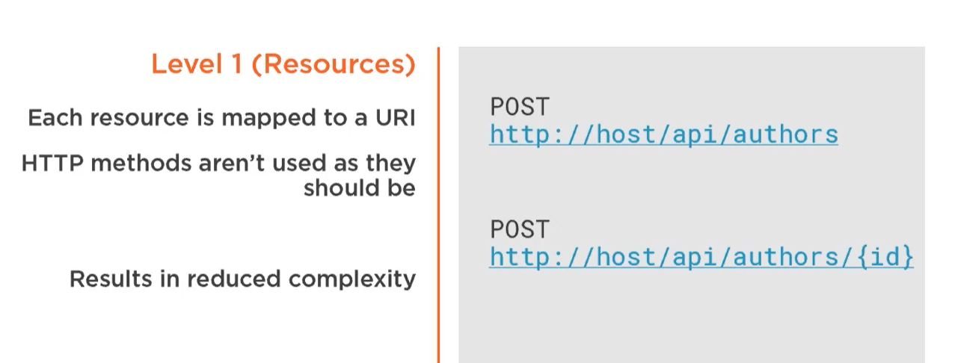

Each object has a particular path.

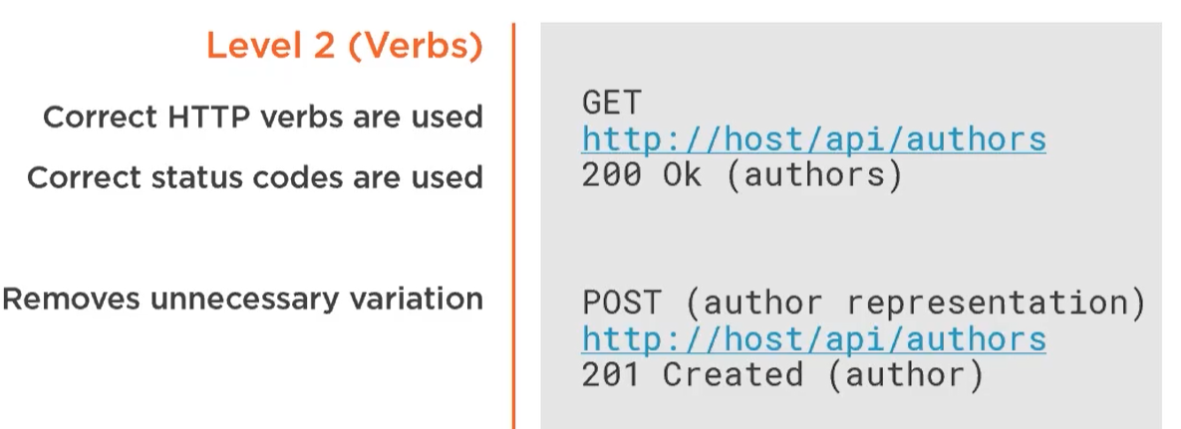

There are http verbs and status code which is implemented in an api.

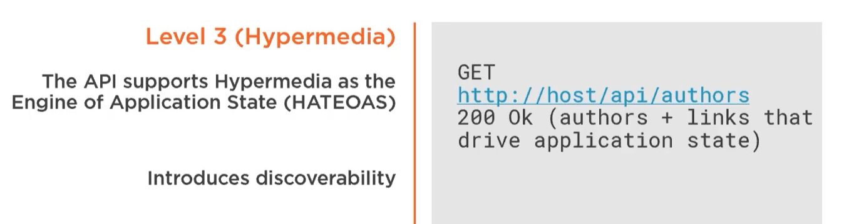

Last level is an implementation of Hateos to cope with application state.

# Structuring and Implementing the Outer Facing Contract

## Structure

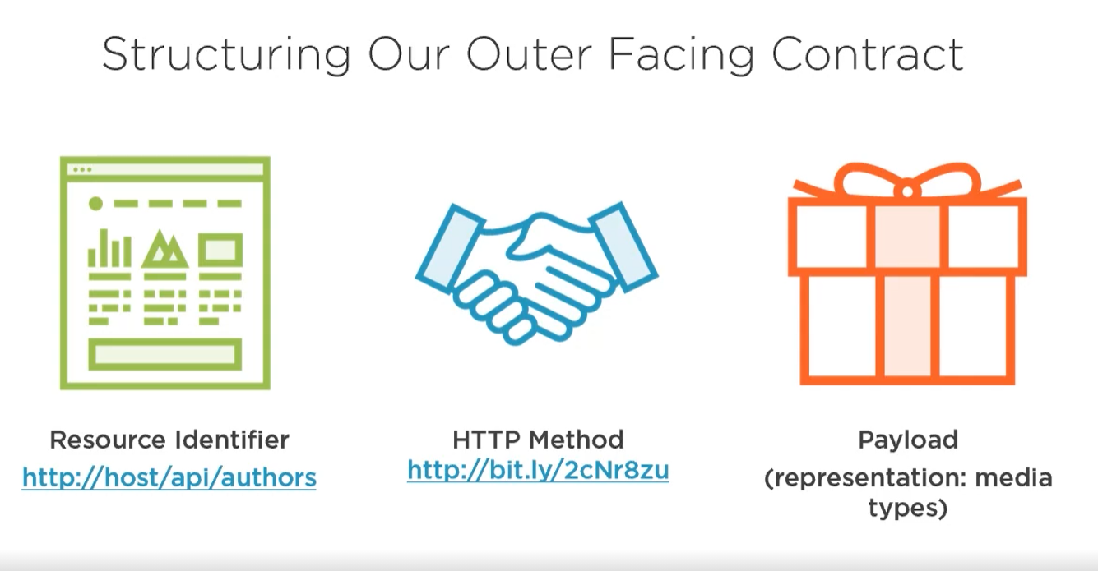

Second level of maturity model.

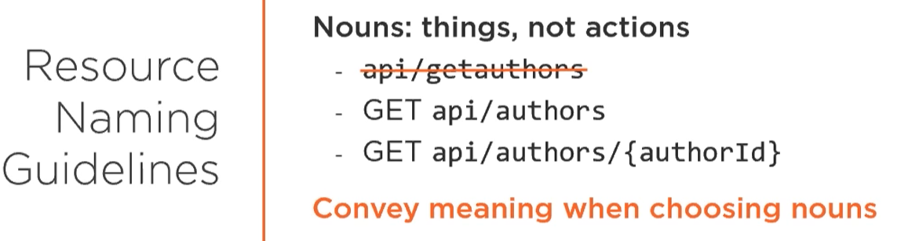

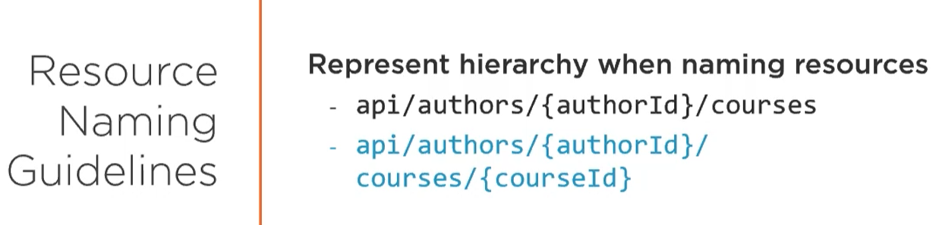

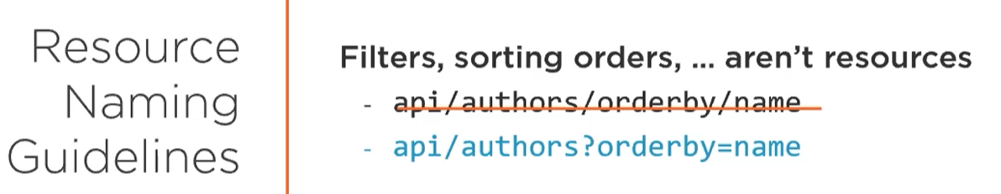

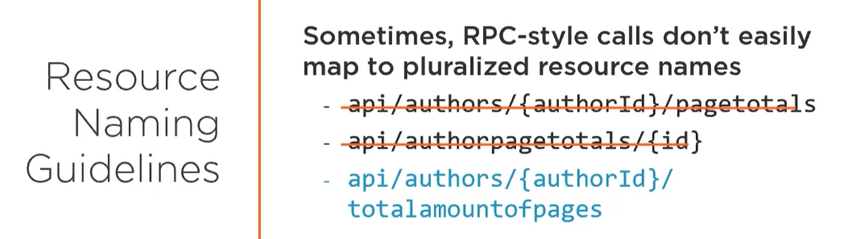

## Controller

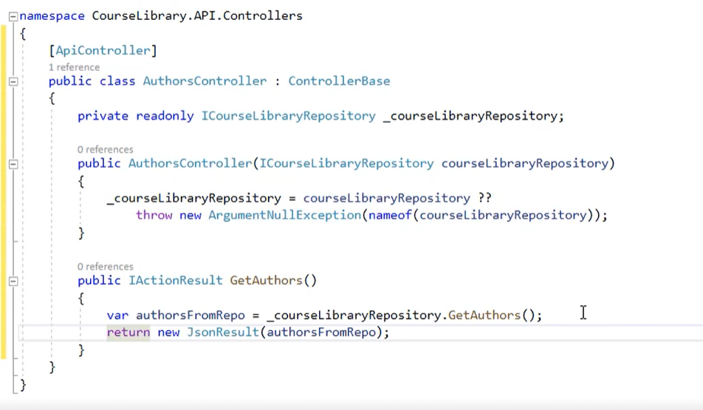

Controller class inherit from ControllerBase not normal Controller like in ASP.NET MVC because controller parent class return Iactionresult as view but we need to return an information in json or xml format. Add API annotation above controller class name to mark as API controller.

## Routing

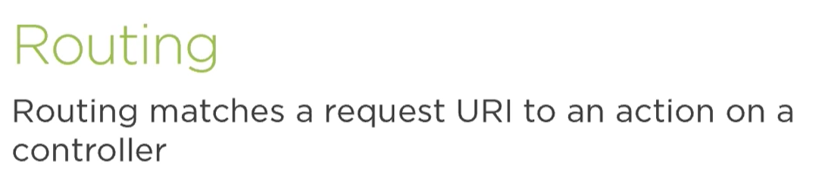

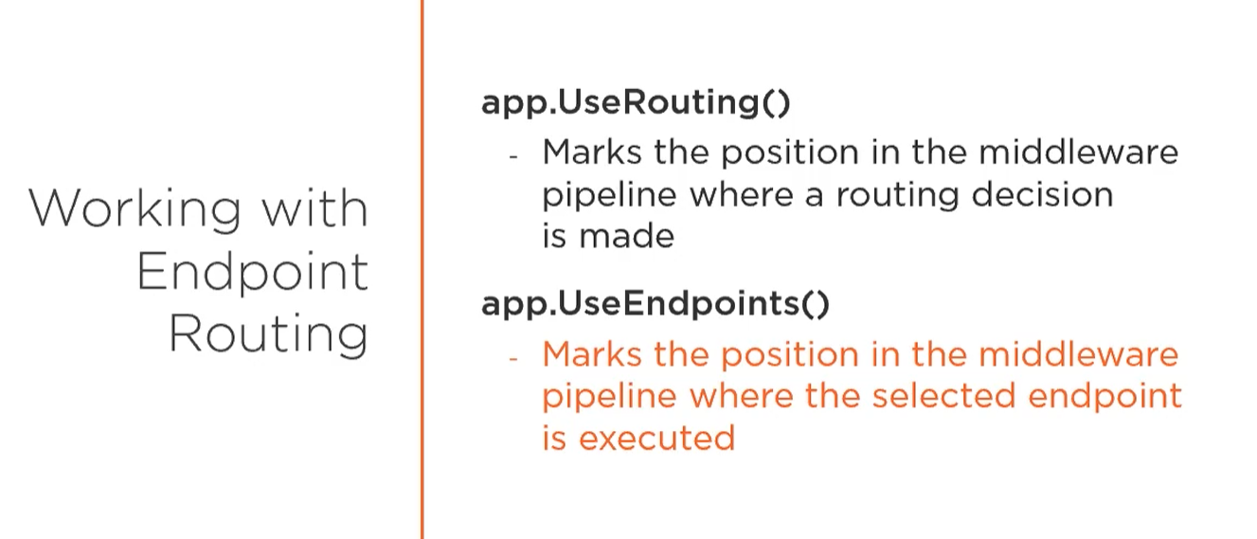

There are two middleware which are required. First one is for select route after that can be added more middlewares, second one execute a endpoint.

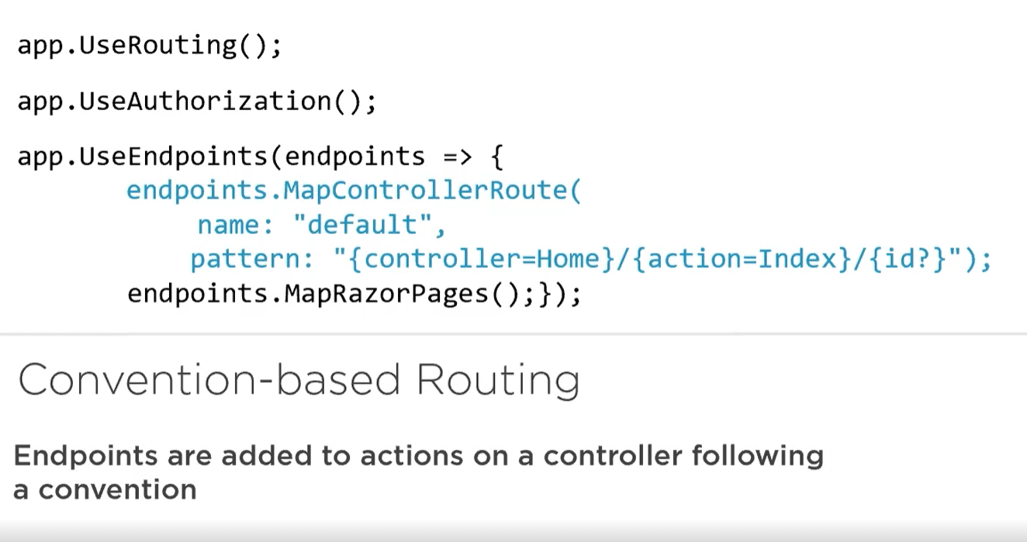

In this example after execute an endpoint is added auth.

There are two ways to create routing convention based and an attribute route. Which the second one is preferred because everything will be set up by dev in controller class is more readable and auto commented code. [Route] [HttpMethod] [etc].

## Interaction

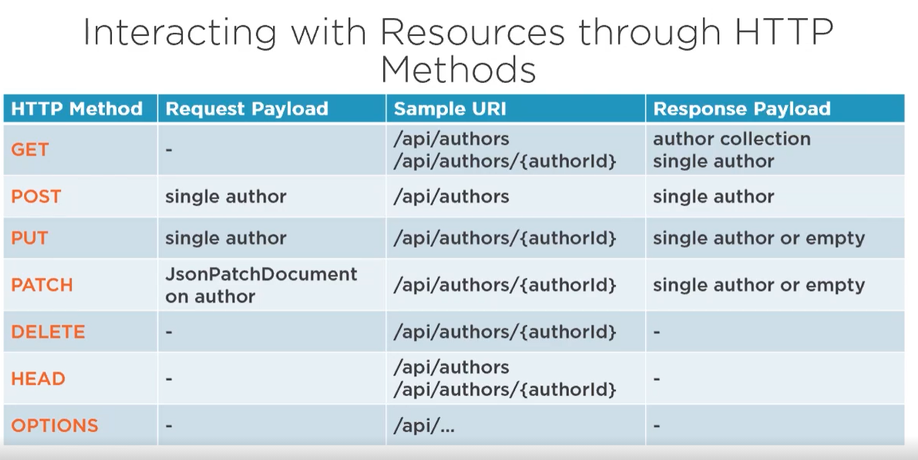

## Implementation of Get

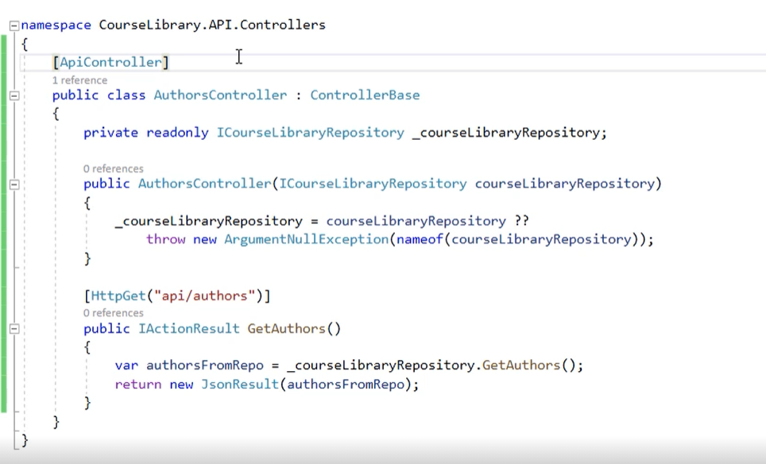

Above a method is added a http route with http method.

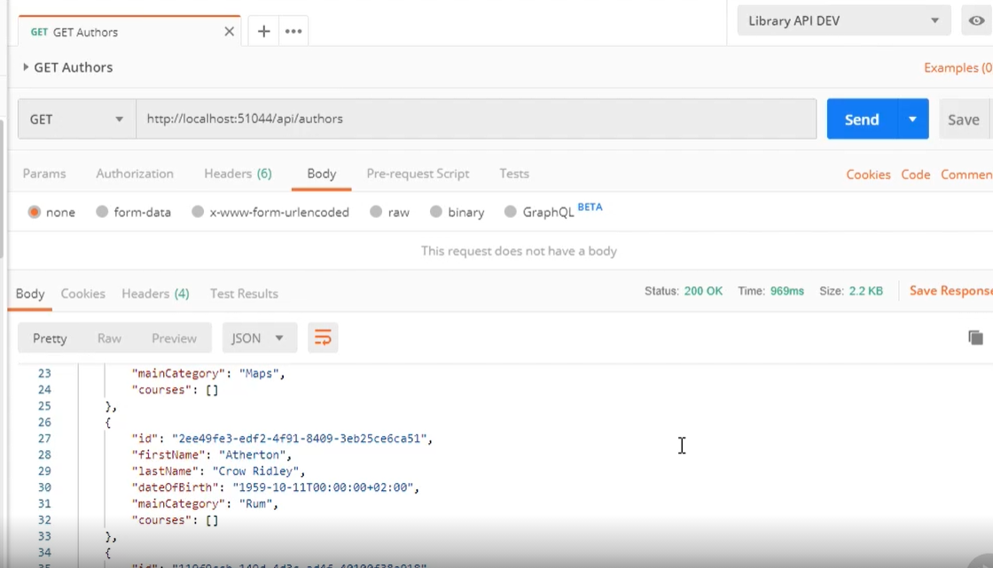

When http request will be fired in a postman or browser or another consumer. Server will send a response with specific data.

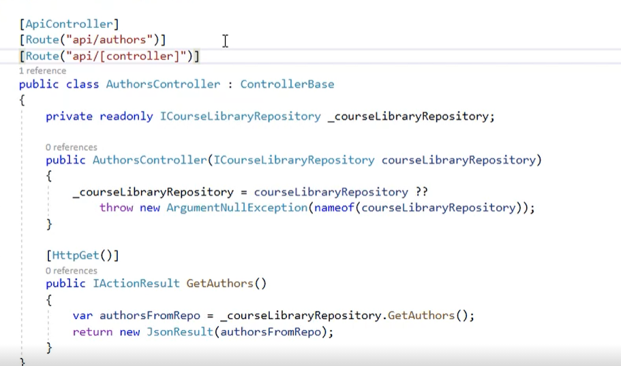

Route can be designed above a method or controller. There is a option for use a default inject to http route.

## Get single resource

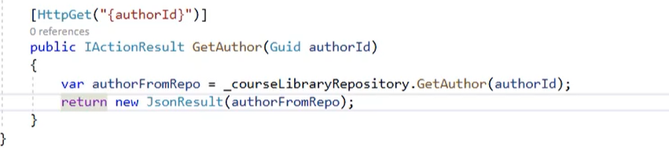

Standard routing like mvc

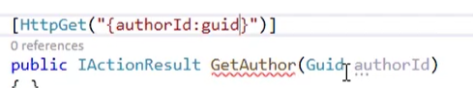

Param can be marked as data type.

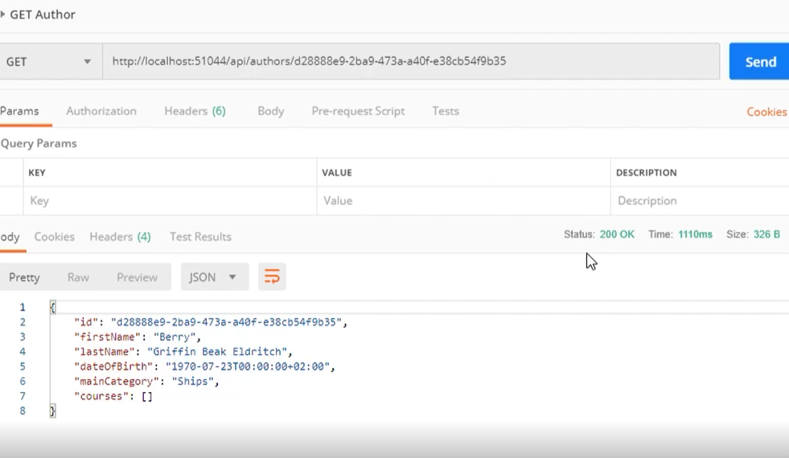

There is a author.

## Status Code

This is an information about action.

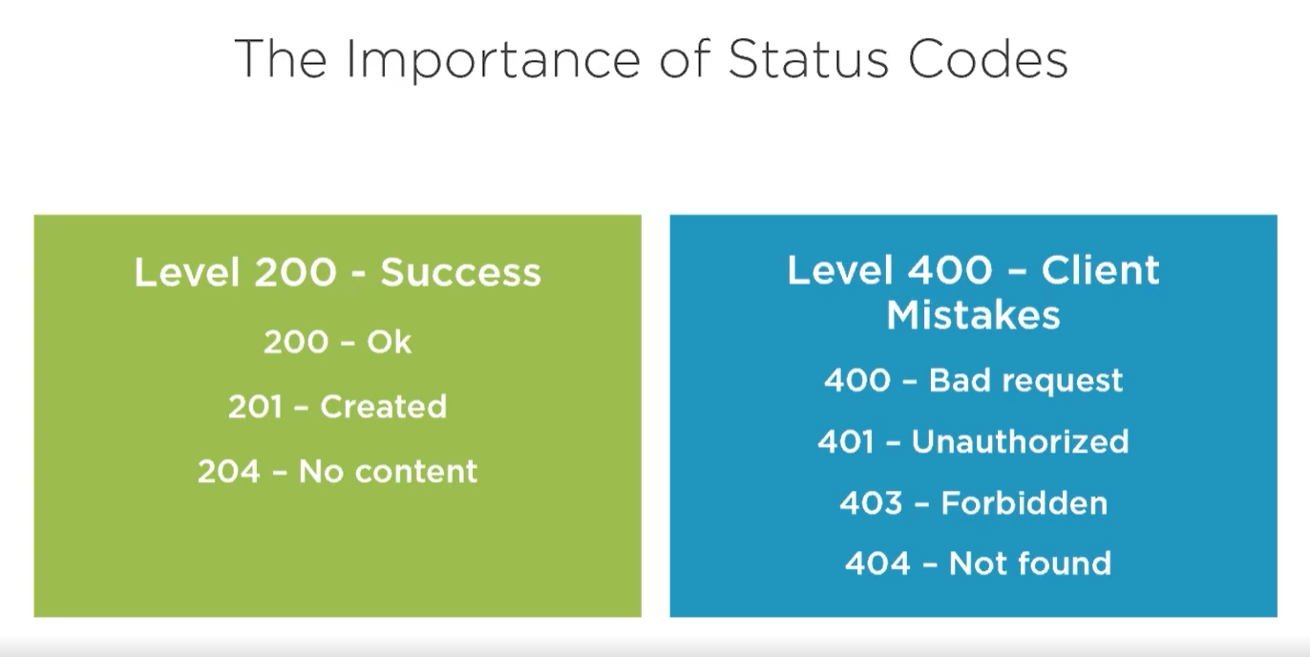

204 is like we delete something, it means everything is ok but there is no object to response.

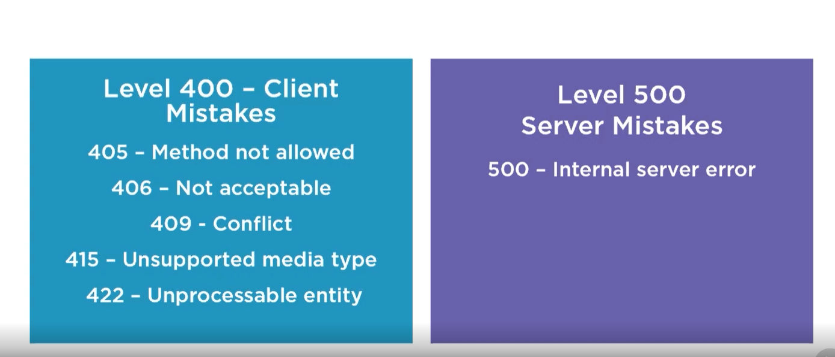

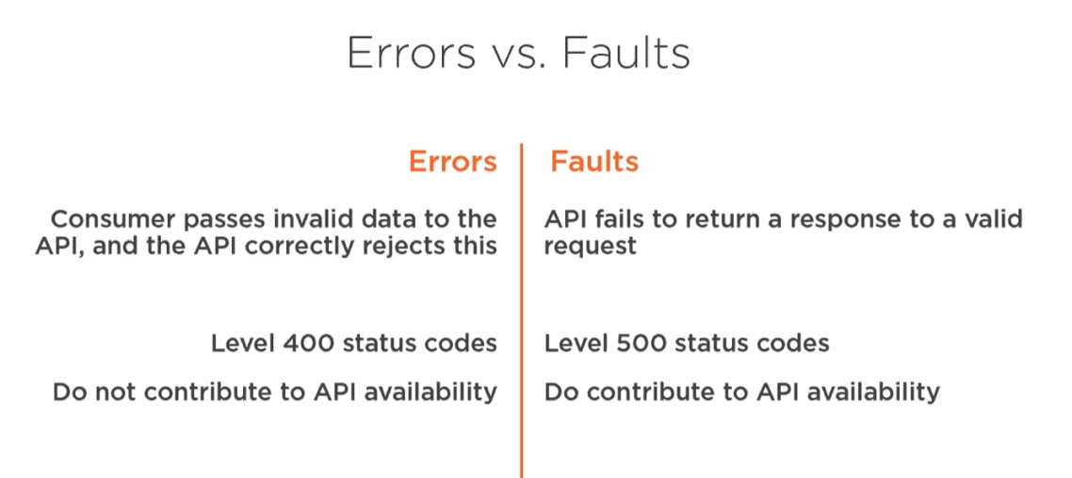

## Return a status code

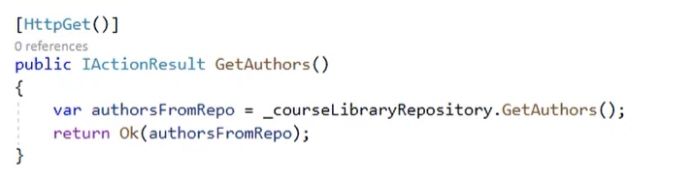

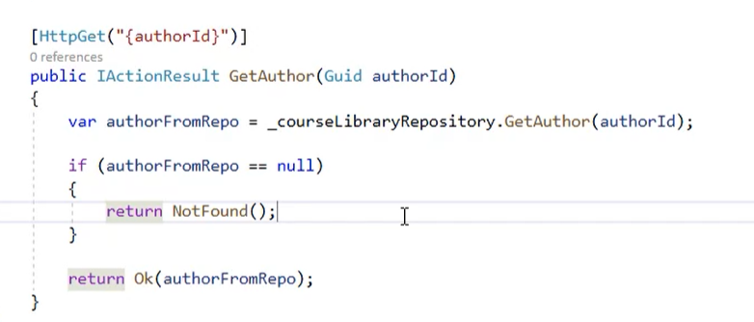

When exist 200 if not 404.

## Formatters and Content Negotiation

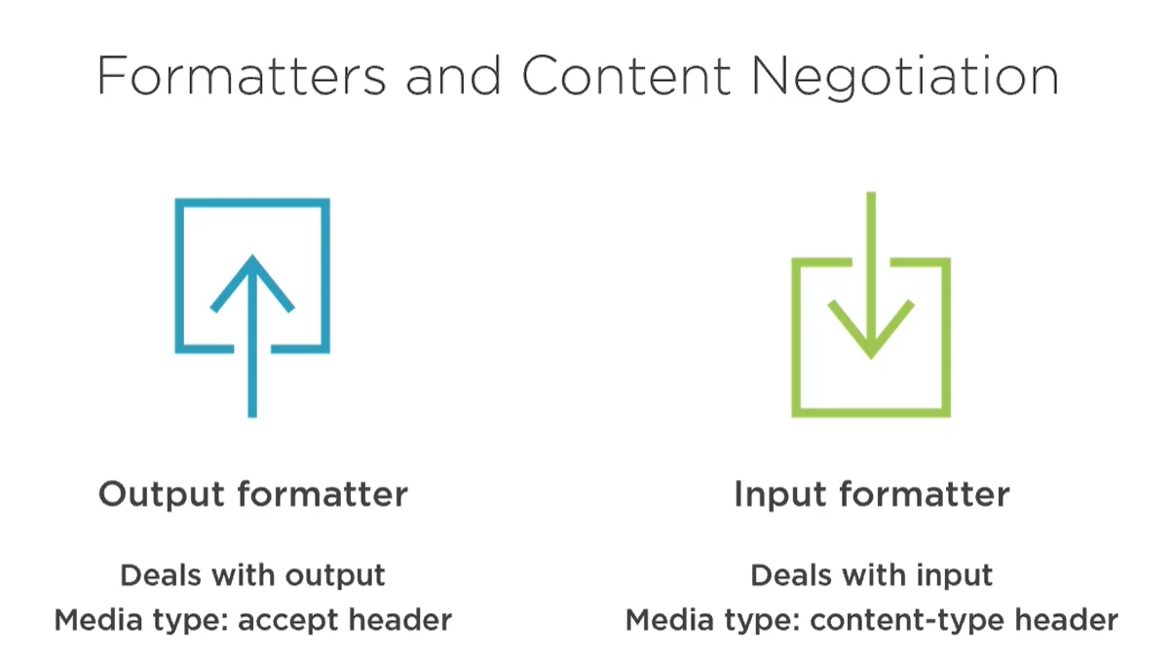

Header is like description what request need to be sent via response. But some of header can be accepted some of course not. It works like a key and lock. Client request a information with matched payload then he get expected value. If payload is not matched to patter client get 406 status code it means not acceptable. Payload can be send as output or input.

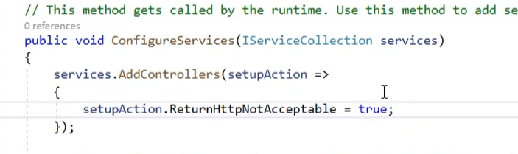

To set 406 required is register that service with param require http not acceptable is set to true. After that when media type is different then return type client will get a 406 status code.

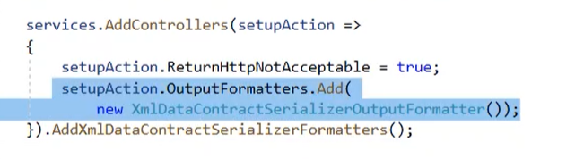

New format can be added in addController method. There are two options first add new object to output formatters or add new method to chain after add controllers.

# Getting resources

## Dto

Data transfer object is used to create more reliable and adequate data which will be send to client. It is VM from MVC

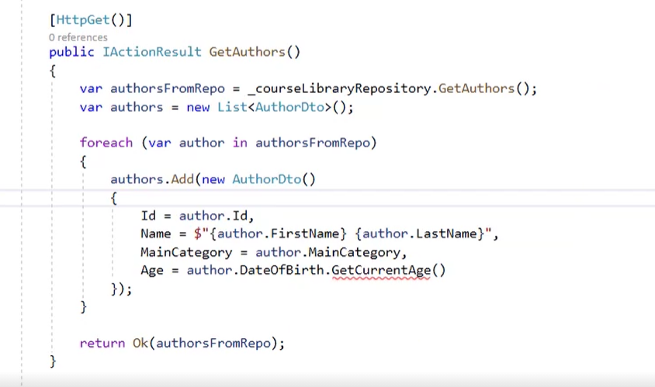

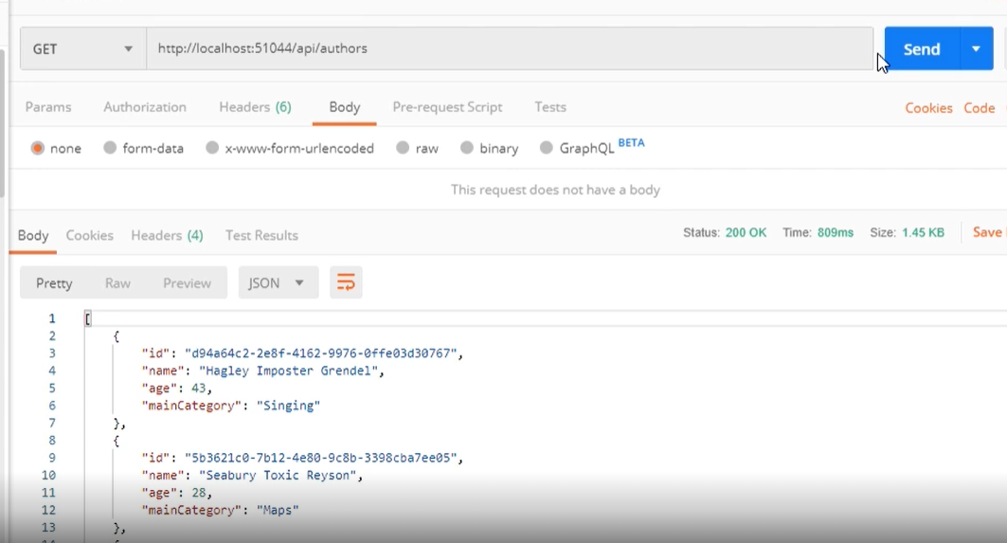

Response now has a dto type object in body.

## IActionResult<T>

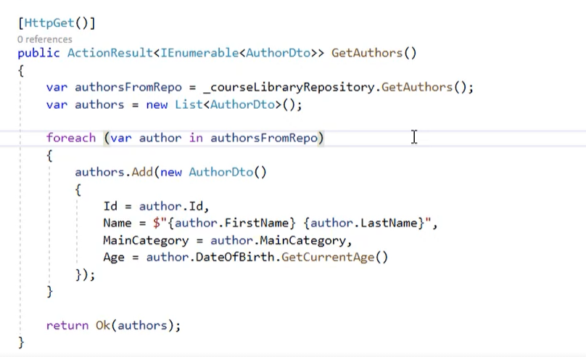

Add <T> to create more readable and auto commented code.

## AutoMapper

Library to create a DTO or VM in easy way.

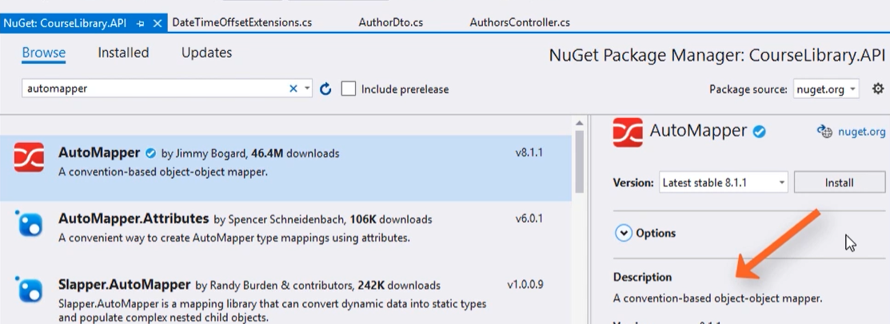

Install automapper via nugget

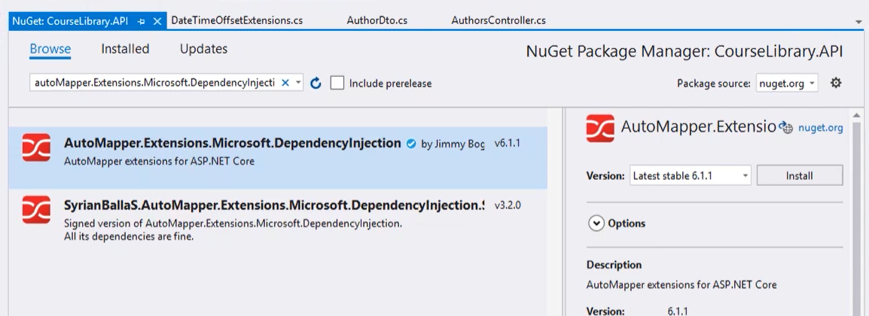

Add DI extensions to AM.



Register in startup

## Using AutoMapper

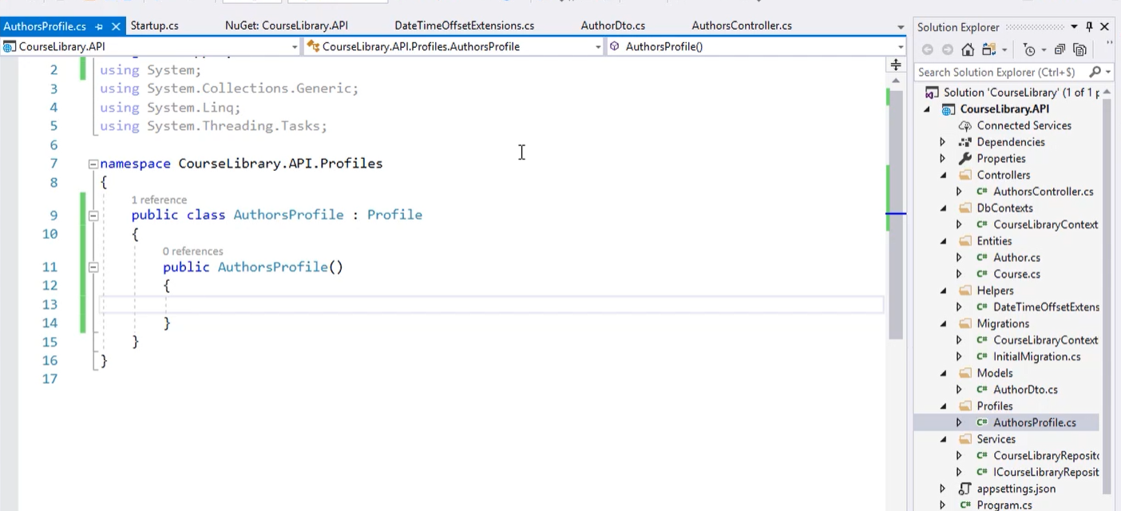

Add profile

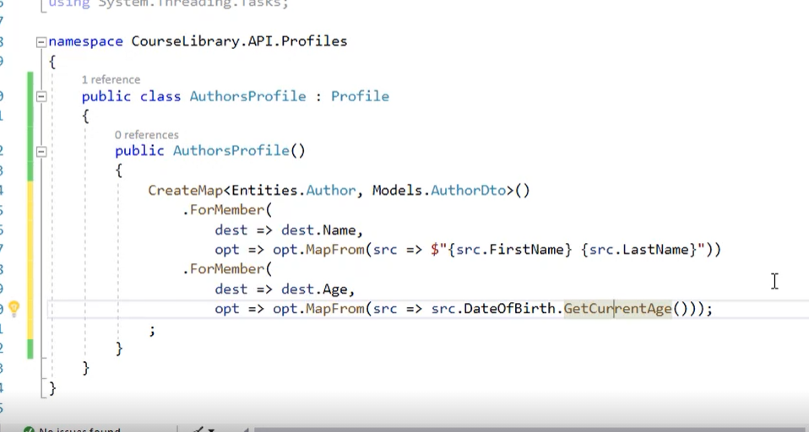

Create a mapping.

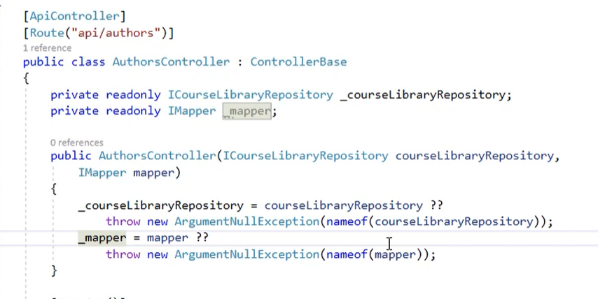

Inject.

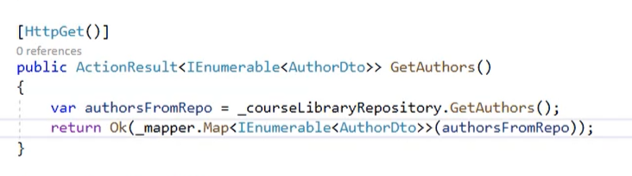

Then use mapper.

## Parent child route

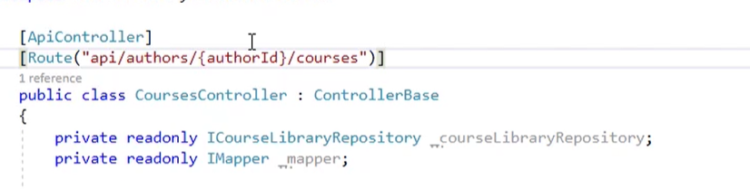

It is an extension for a parents route. To get a child object required is an id of parent and then specific child class.

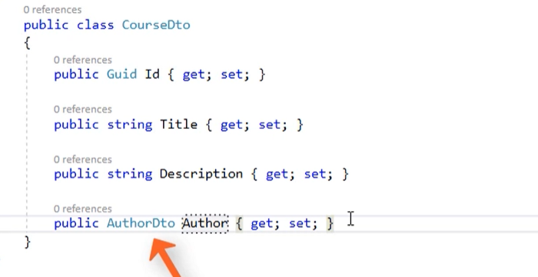

Add CourseDto to project. We don’t need a whole object. It is better to use a Guid of author.

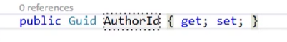

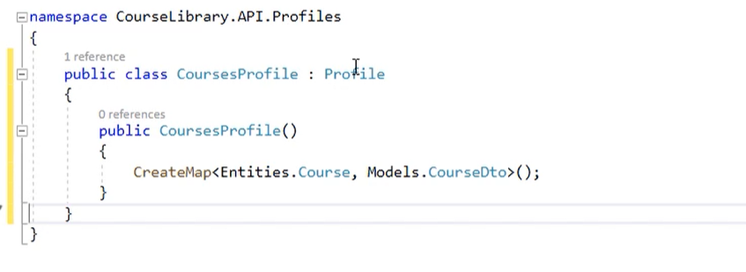

Create an profile for course.

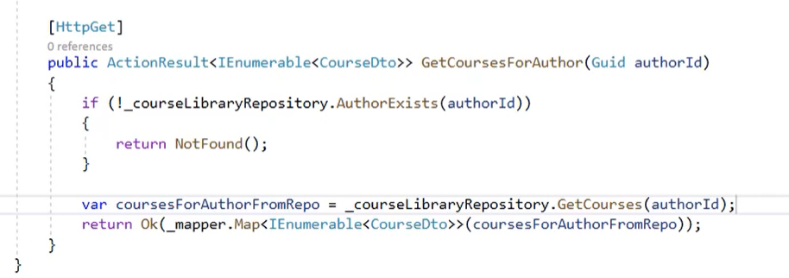

Implementation to get courses like the same the most important is a route above a controller.

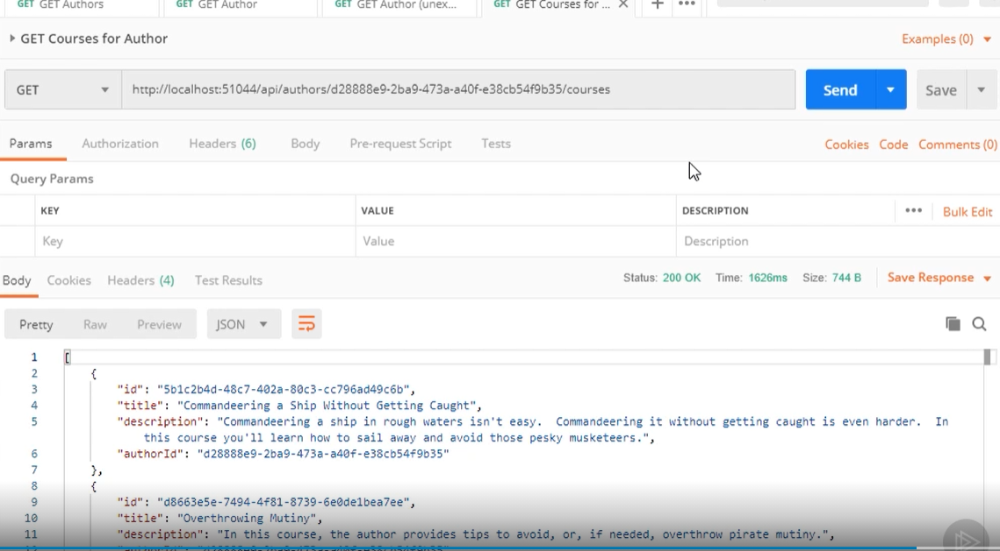

And it works.

## Get a single child

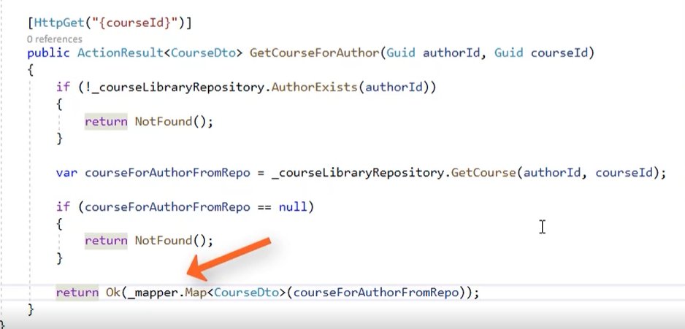

Implementation works in the same way like in normal object. But in child required is check a parent object exists then child and if everything is fine return a object with status code.

## Handling a faults

There are two options. Let’s talk about the first one, extent a environment as dev and add exception handler in else statement which sent information about fault in your preferred way.

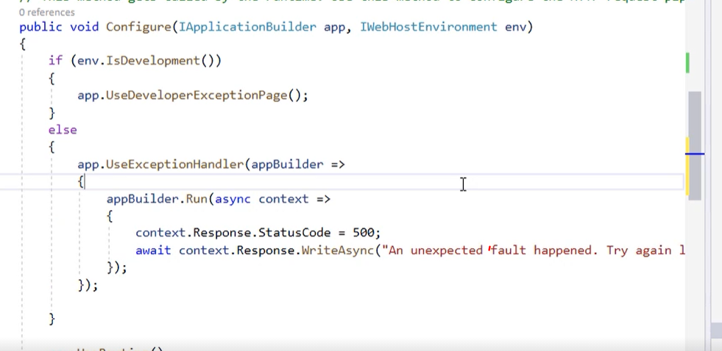

Second method is set an eviroment in properities to production

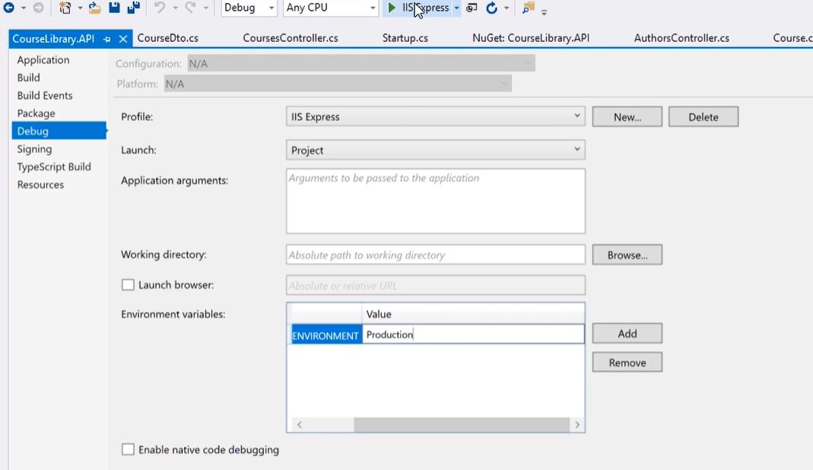

This method doesn’t display an information. Both methods are better than whole stacktrace with exception.

## Head Http method

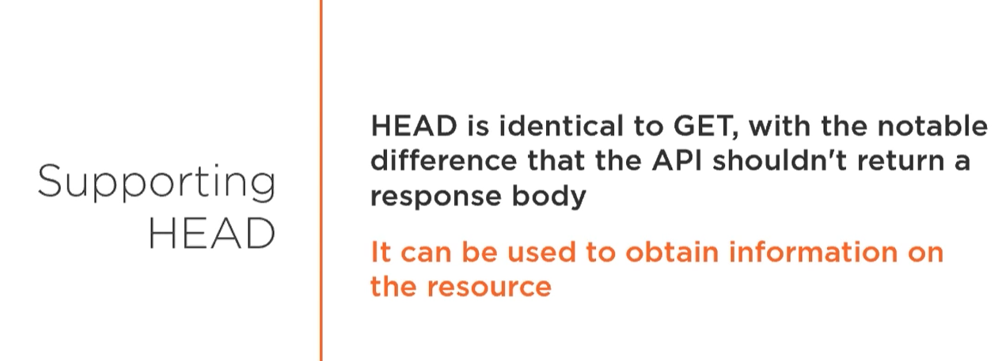

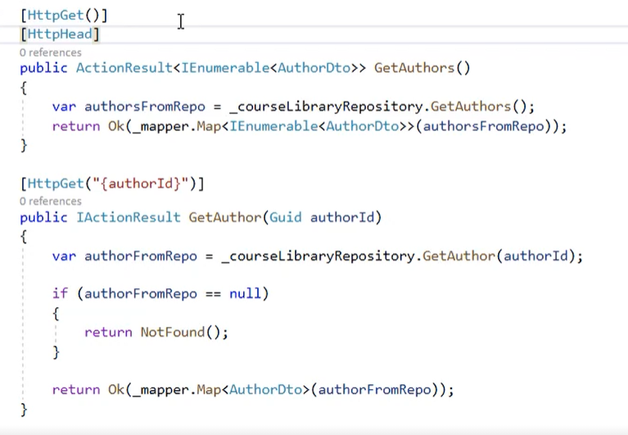

Add head above a method to allow client sent this type of request.

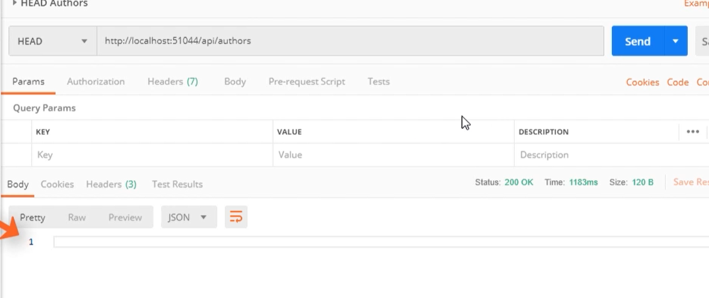

Status code works in the same way but there is no body.

# Filtering and Sorting

## Passing data to the API

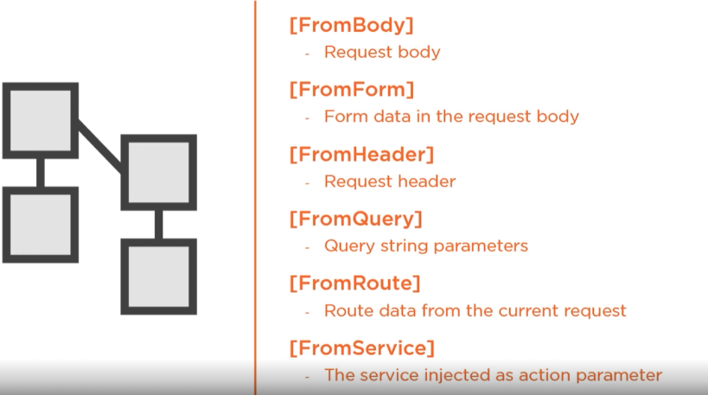

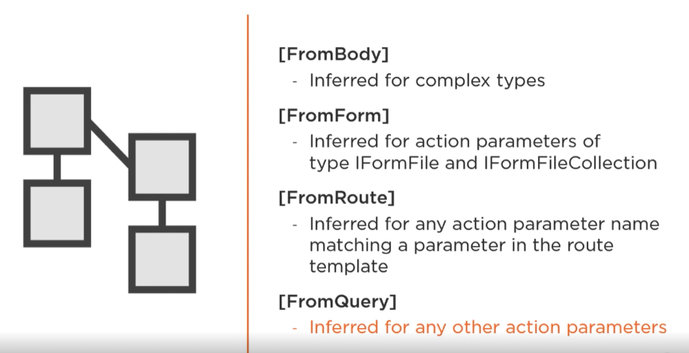

Used in ASP.Net API

## Filtering

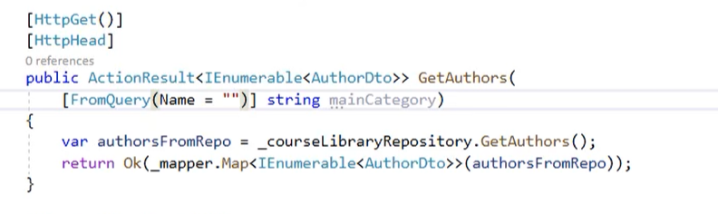

In method can be added a FromQuery attribute with default name, but there is no need to use this type of annotation.

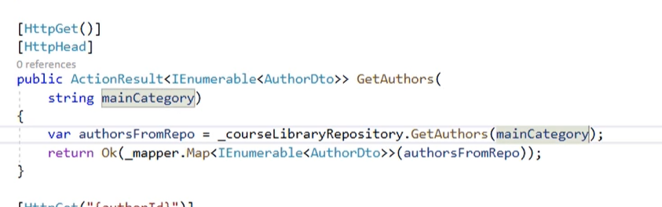

Create method in repo which filter data and launch in postman.

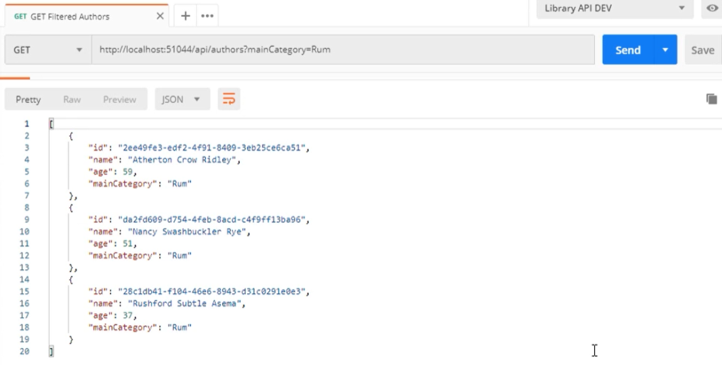

A param is added to URI after question mark and there is an adequate name of filter and var which will be used in filtering operation.

## Search

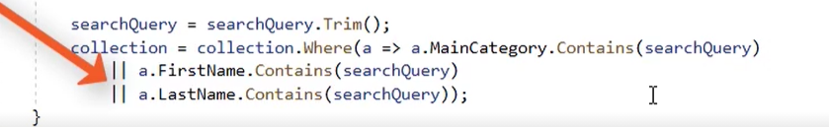

Return a particular data which has a matched property to search query.

## One method to rule them all

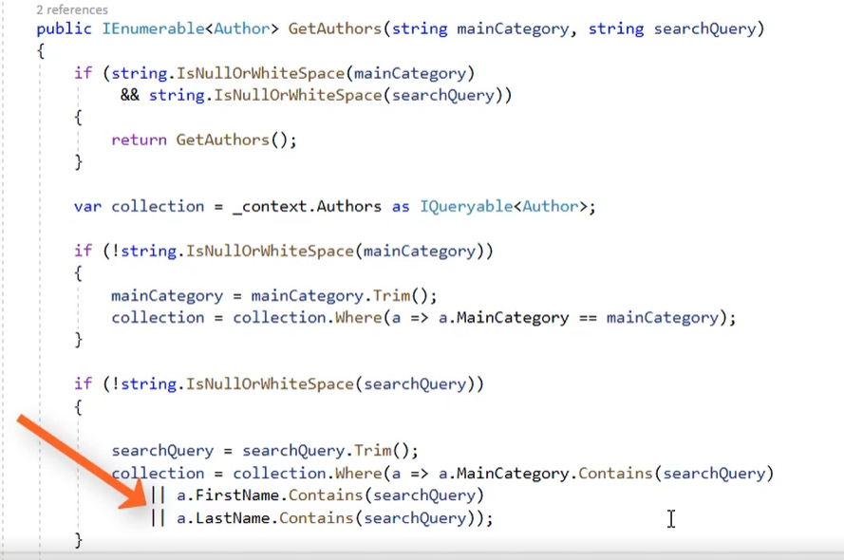

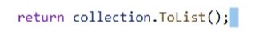the last line of method.

A method can have a search or filter params together. And with special if statement it can be filtered of course is relly bad practis because better is create method which is responsible for only one piece of action not for all.

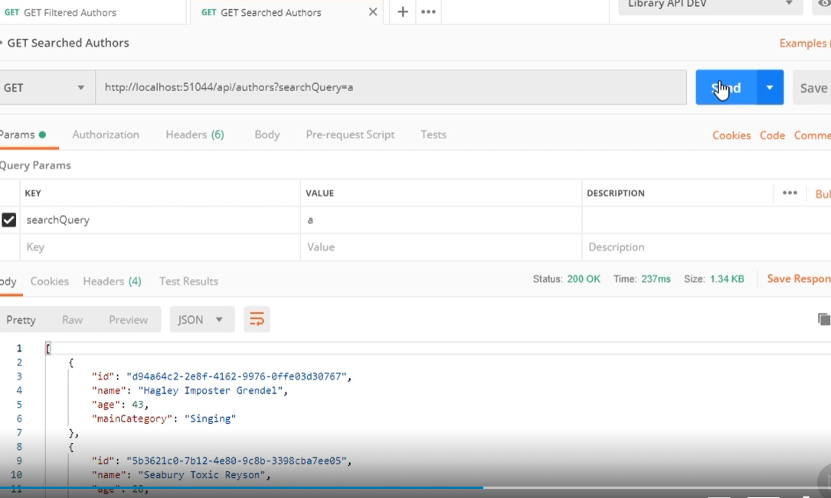

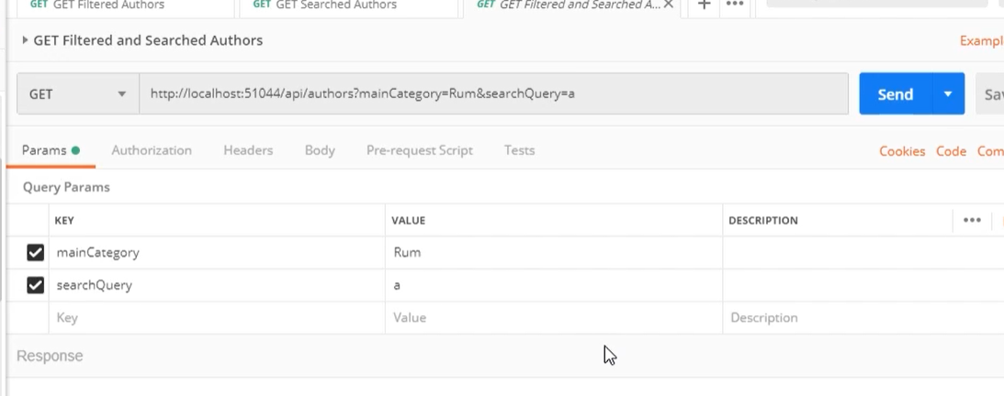

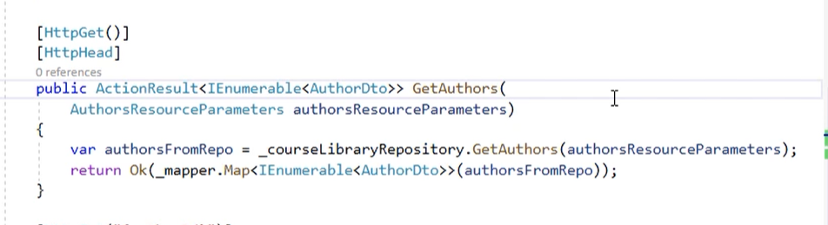

Filtering category can be wrapped in a object.

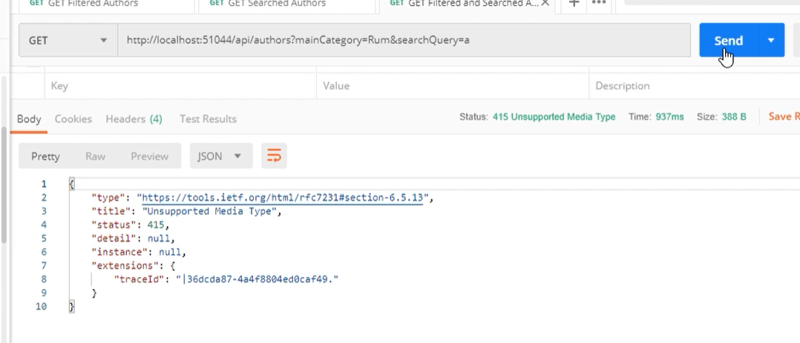

But if we don’t add before object [FromQuery] annotation. There will be a 415 unsupported media type.

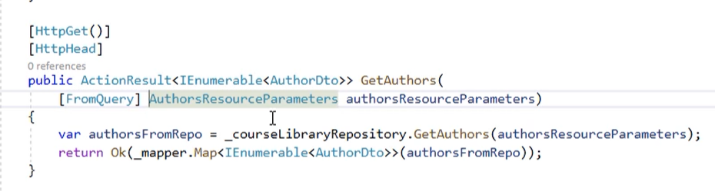

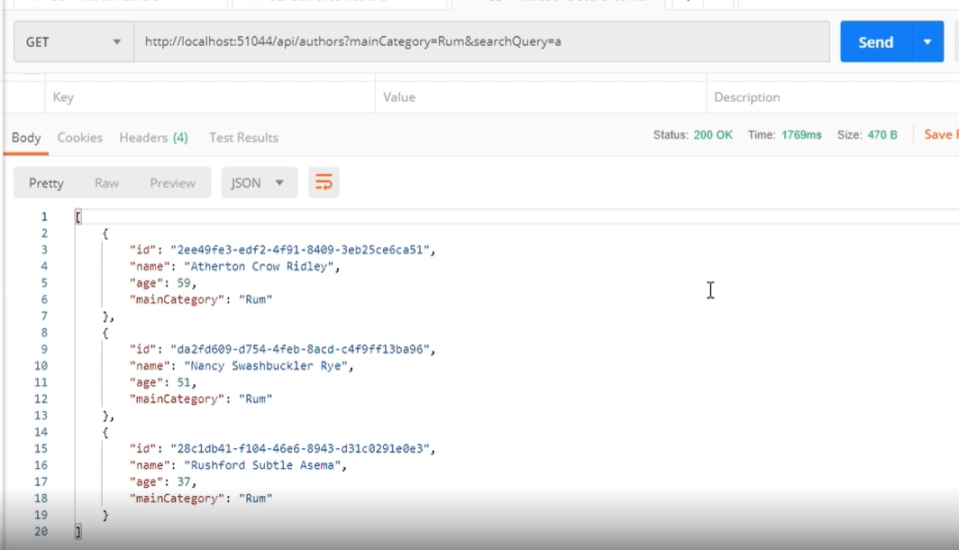

With annotations works fine.

# Creating resources

## Idempotency

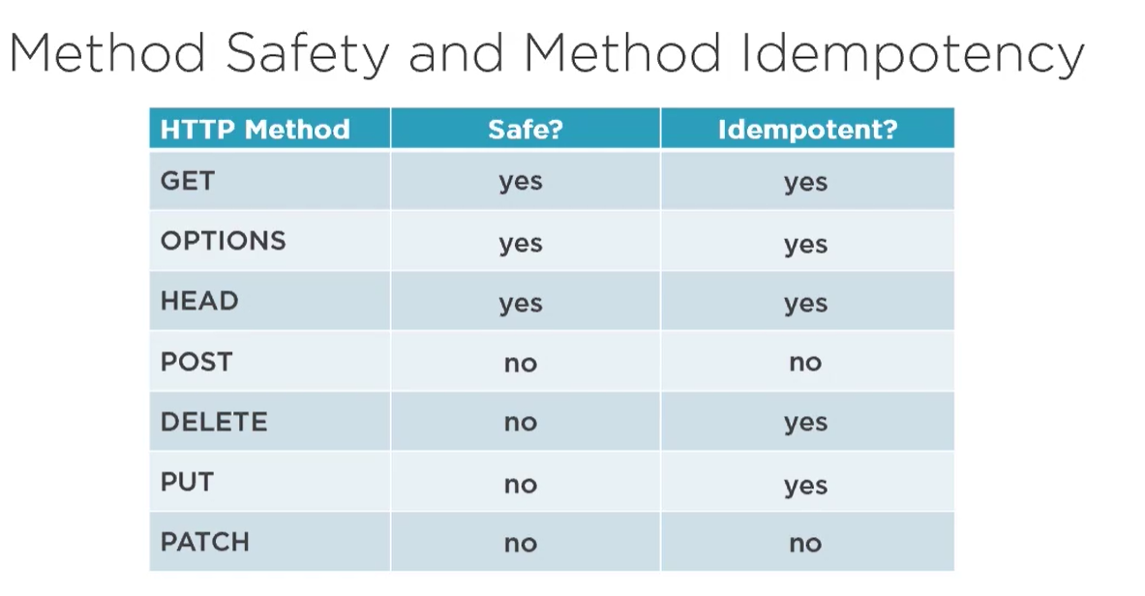

## Post first object

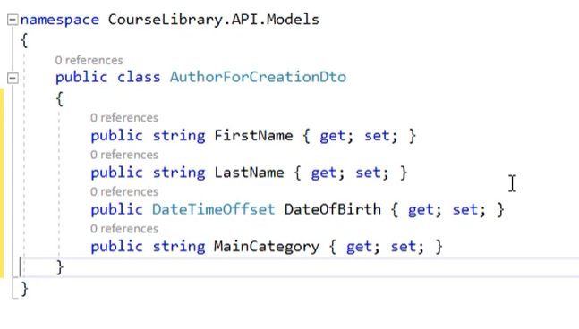

Required is suitable Dto class.

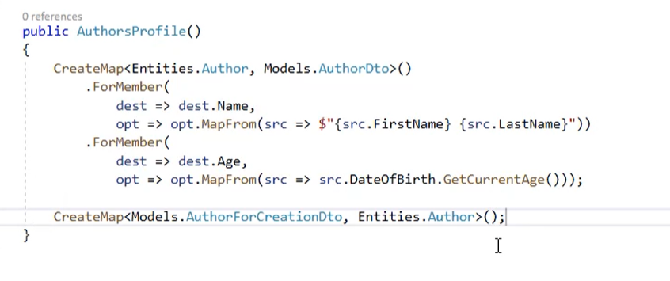

Then add mapping or reverse mapping if you prefer.

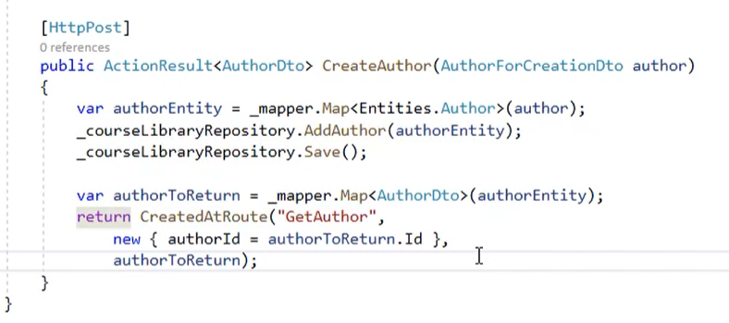

After that create a path with returned status code and object id if you prefer it can be a whole object.

Method which will create object required a body with adequate param.

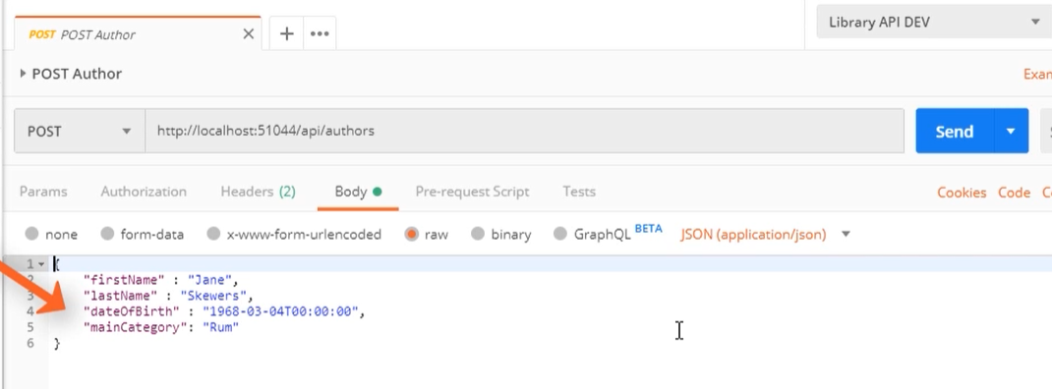

When request will occur propertly. Server will send 201 status code and object in body in response.

If requedst doesn’t have matched body or http method it will be returned a 400 bad request code.

## Create a child object

It works in the same way like nested route in get. Steps to create a resource all the same like in normal creation. Create DTO, method etc.

But method required a author id because a child object are assigned to specific parent instance and of course body with object to create.

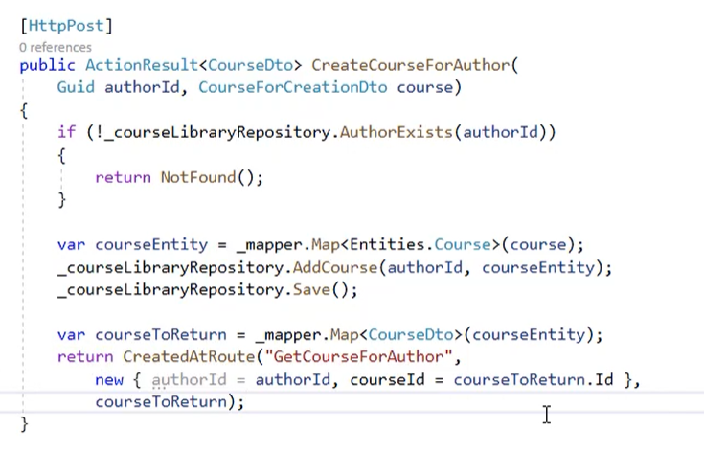

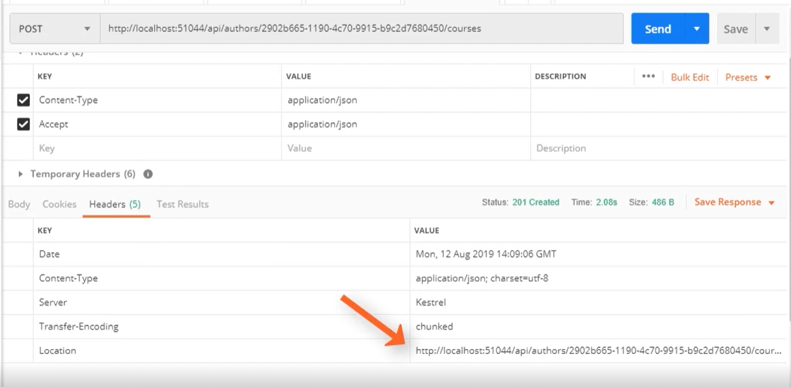

In header location is added a uri to created object.

## Create a Parent and Child

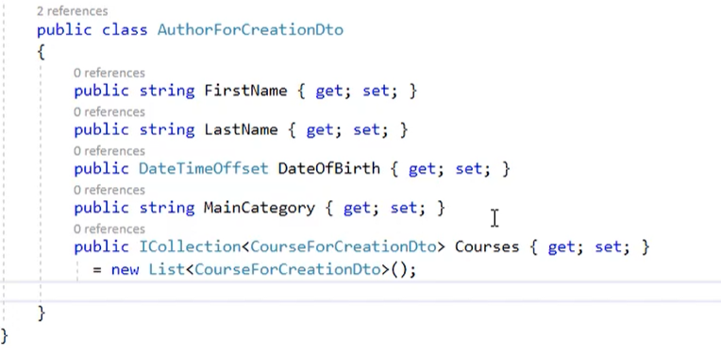

Add list of children to parent dto.

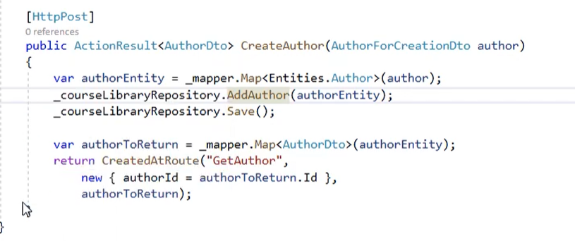

Use a normal create method. DbContext is tracking a object and save all neasted object which has and table in DB.

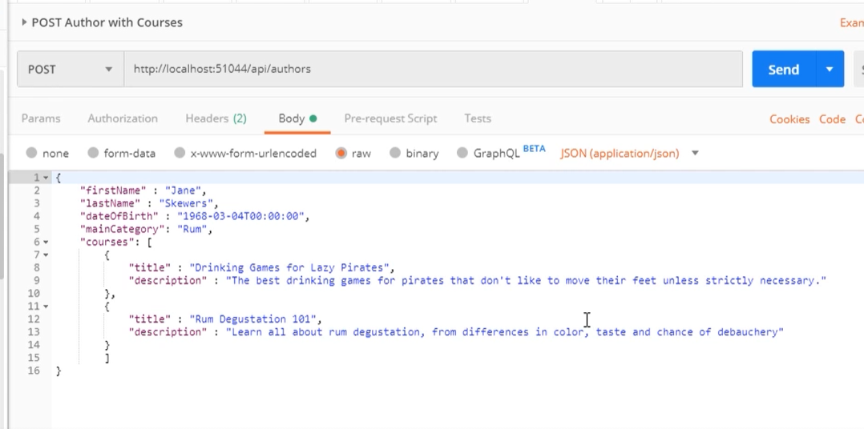

Send body with parent and nested children.

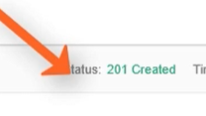

After request, a response is a 201.

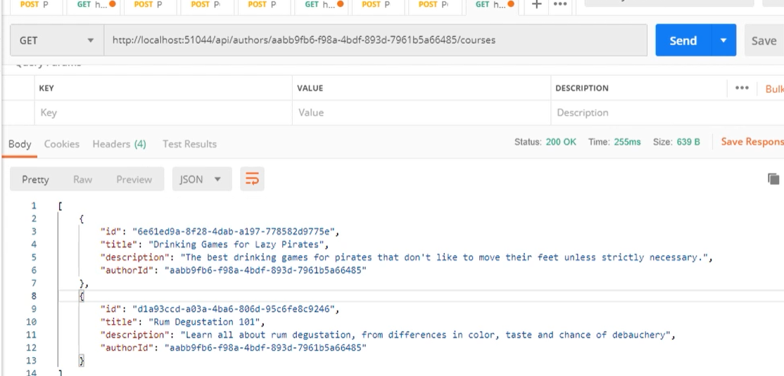

And children has been added with parent too.

## Creating a list of objects

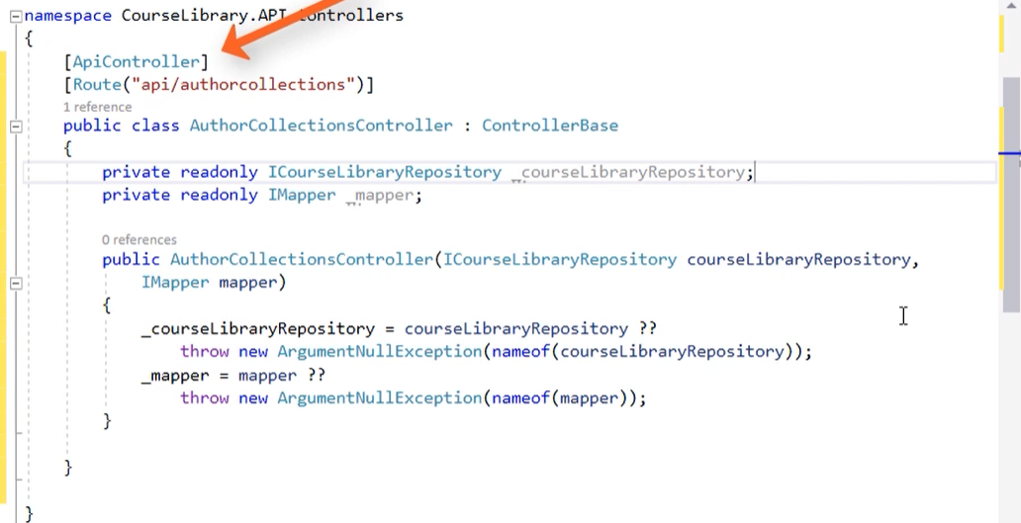

Add new controller with route.

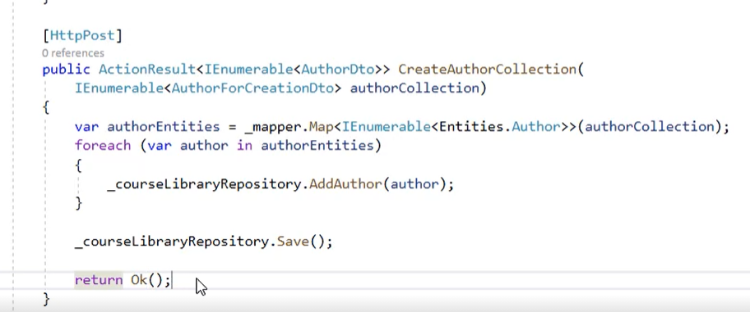

Then create a method with specific dtos in list required as body.

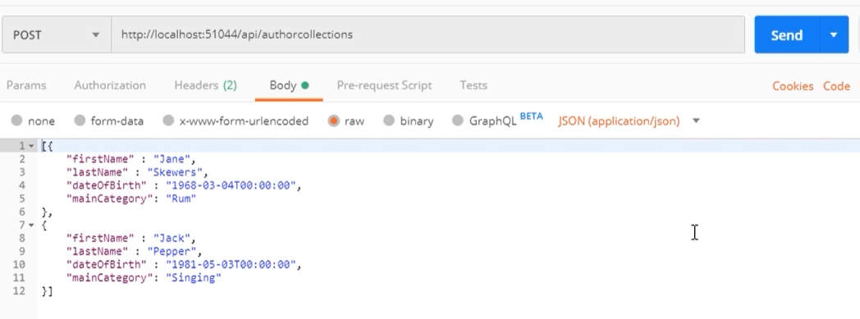

Send request with list in body.

## Deal with location of objects list

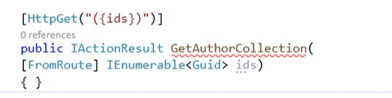

Create method which return a collection of keys.

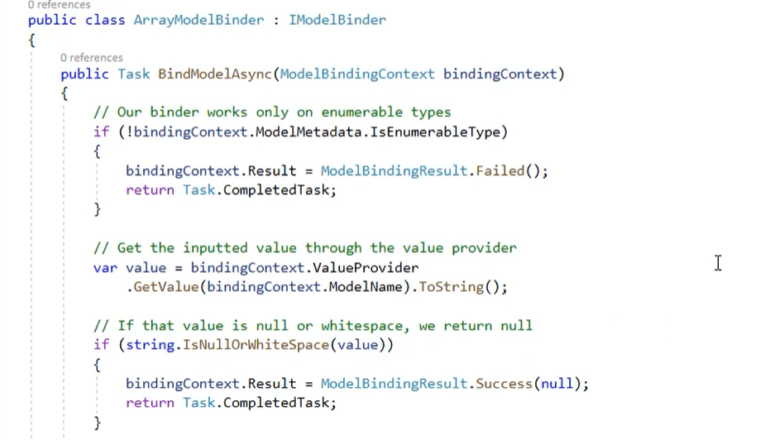

Create a new class model binder.

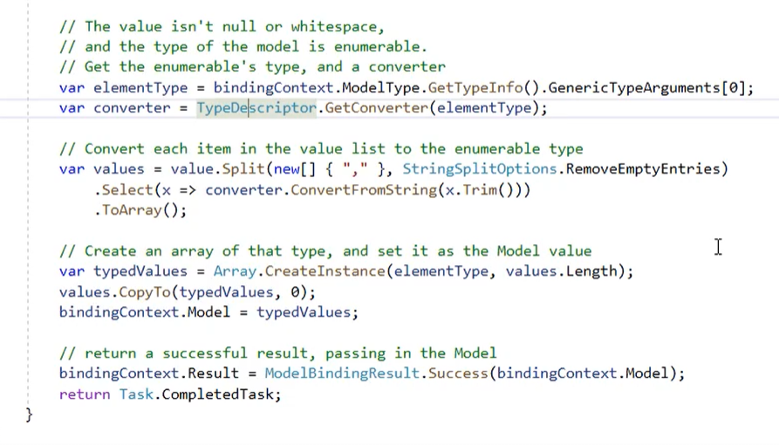

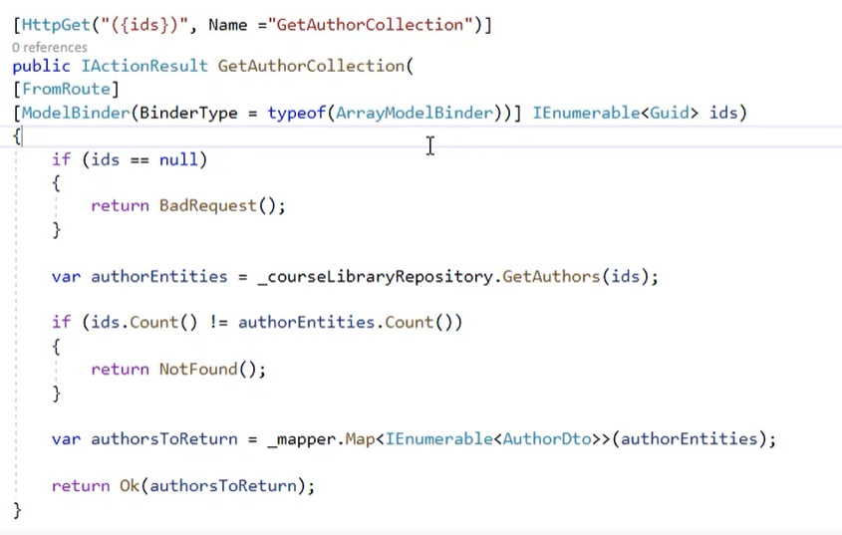

Then change a method and add model binder to param and assing to collection.

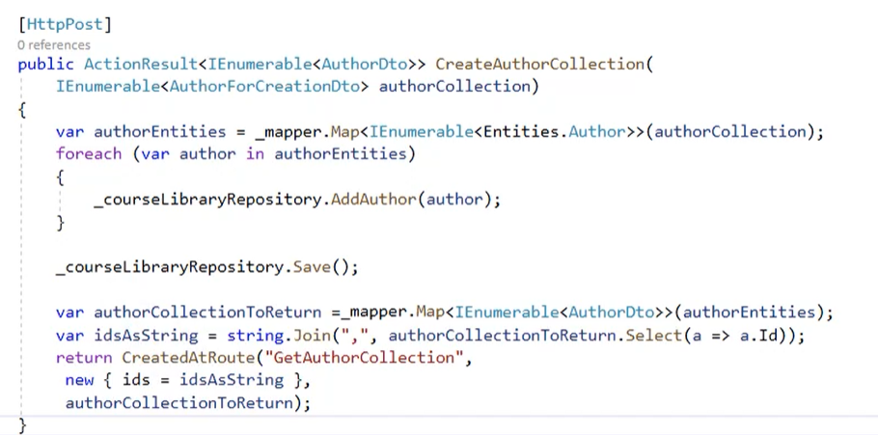

Then change status code in create method.

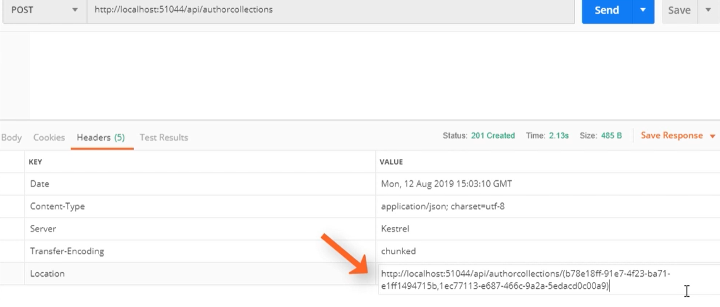

After this setup from all keys will be created a composite kye with is used as param to specific resources.

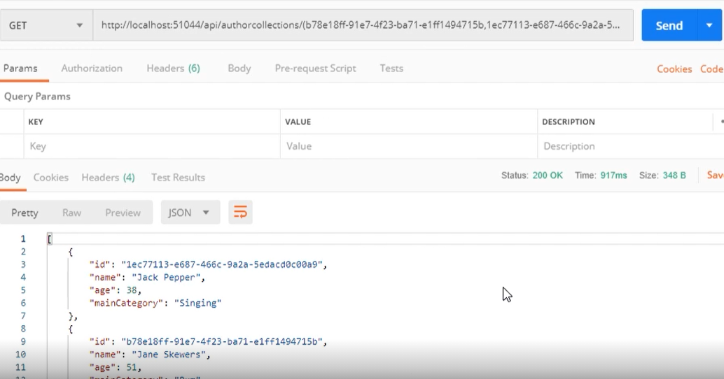

Send this location URI and get list of created authors.

## Post to specific resource

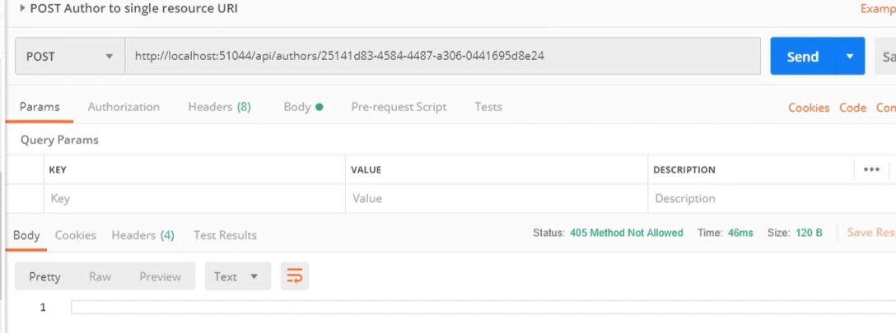

It should return a conflict 409 code or not allowed 405.

## Options

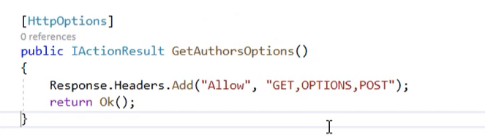

Return an allowed options in API.

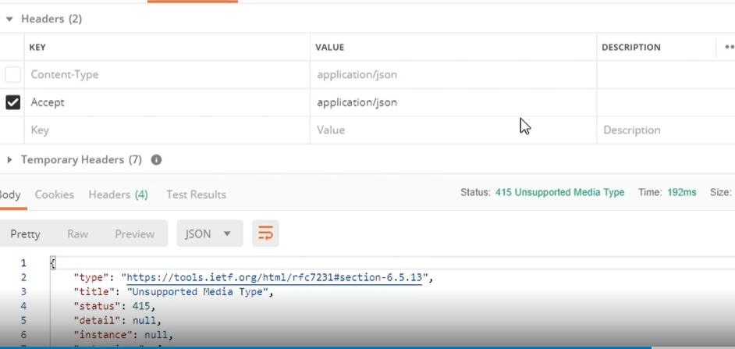

But to send successfully an options method required is media type. Otherwise it will be 415 status code in response. Remember add another media type too like xml.

# Validate Data and Errors

## Introduction

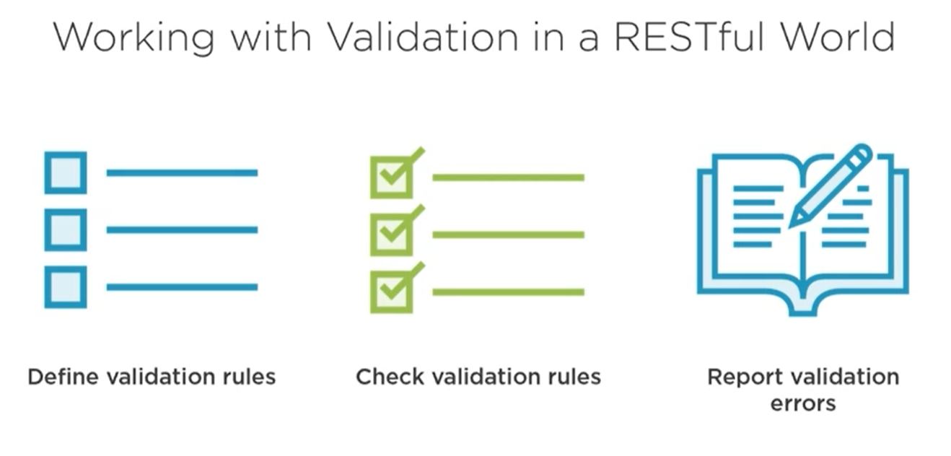

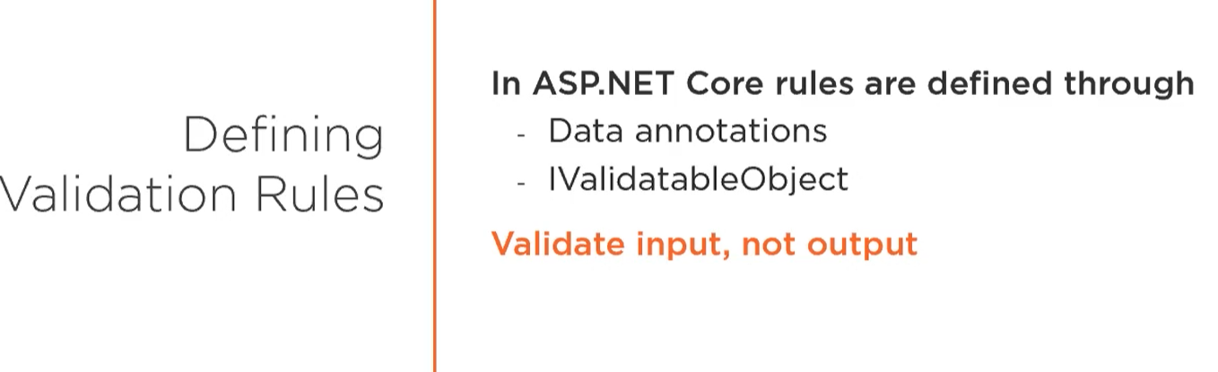

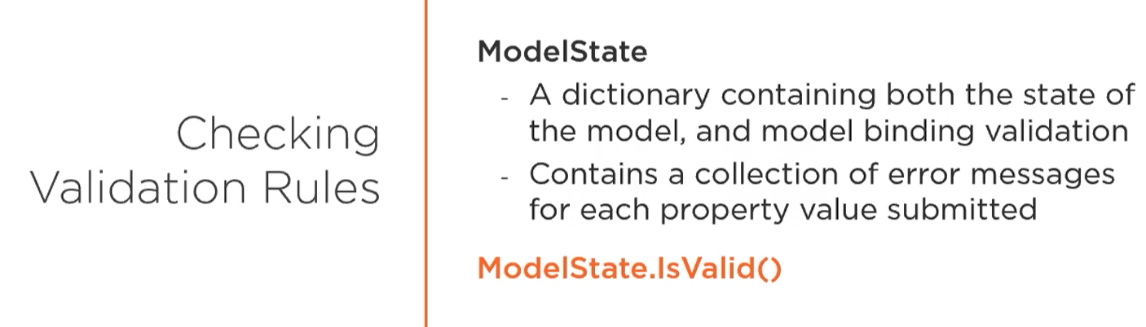

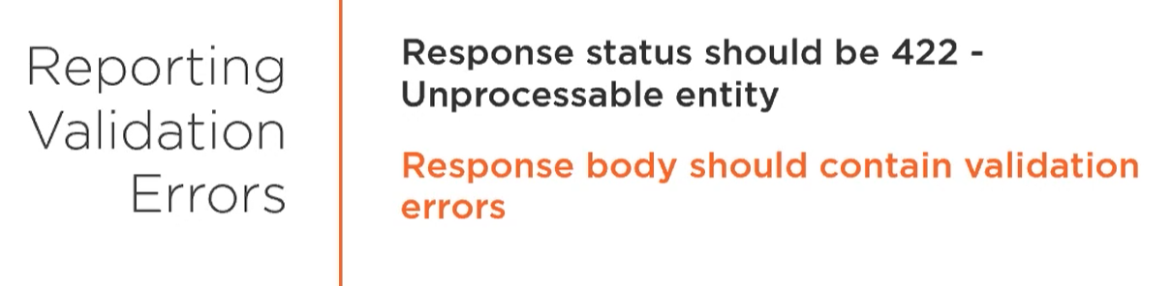

## Input validation

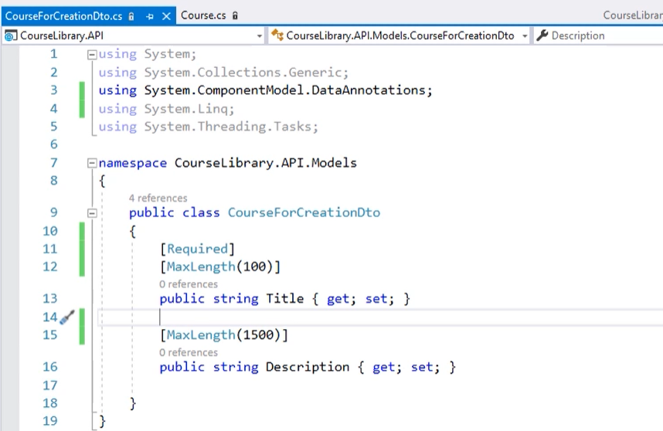

To validate an input required is System.ComponentModel.DataAnnotations. This library give access to annotations which check that property is input in good way. When object in body has empty fields then server return an error 400 with an information about occurred problem.

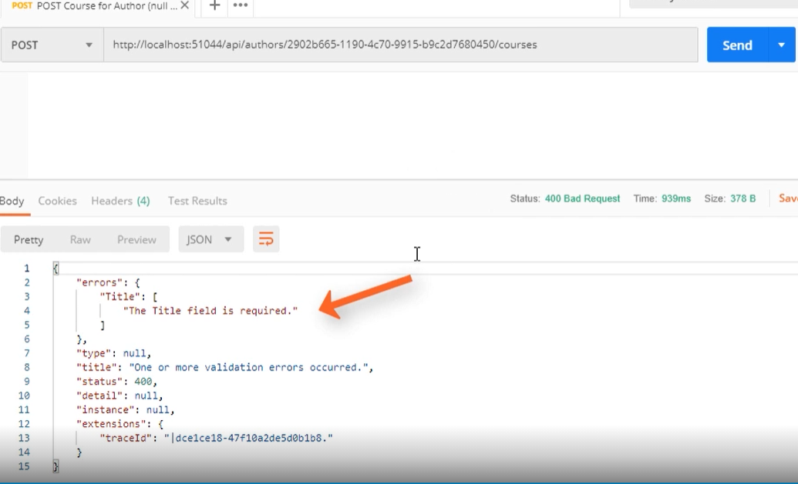

Error is returned by ModelState object. Which invoke IsValid method.

## Custom Class Validation

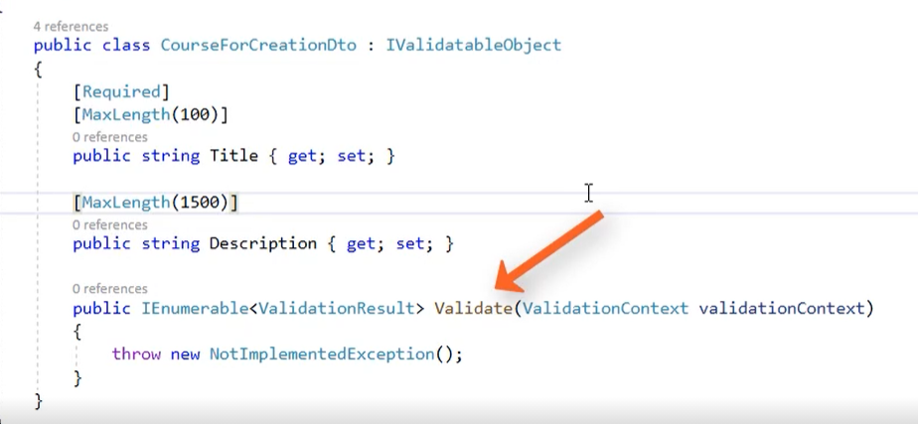

To make own validation, implement an interface IValidatableObject. In added method Validate create your own validation rule.

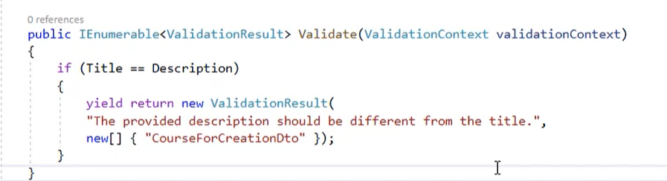

Yield return send an output immediately when problem happened.

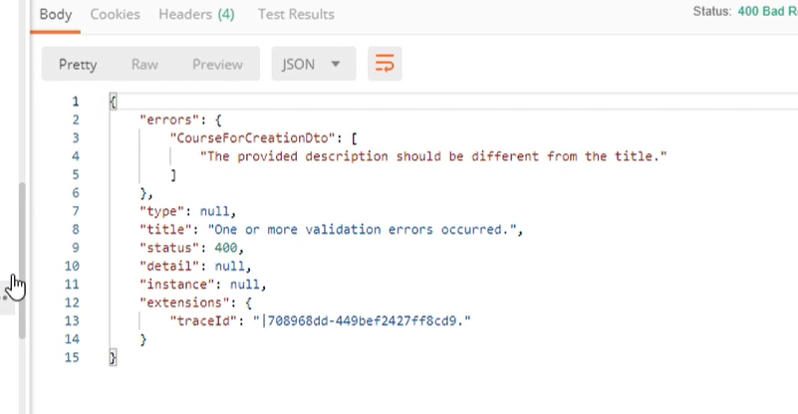

## Validation Attributes

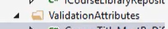

Create a folder with validation attributes.

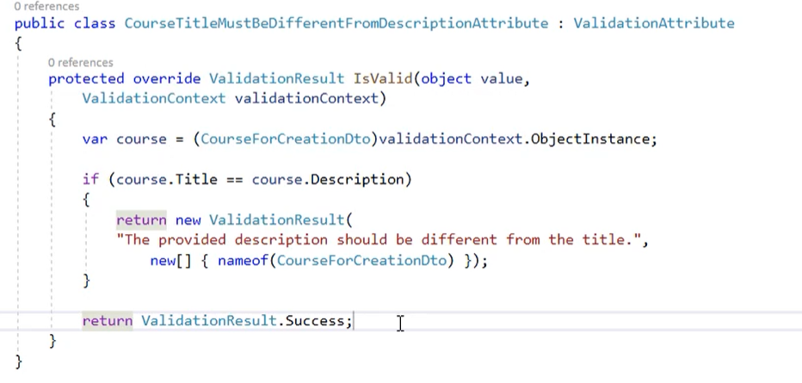

Inherit method from ValidateAttributes class. Write your own validation for property.

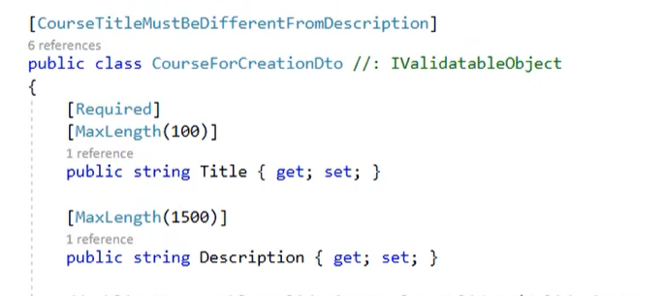

Add validation above class name.

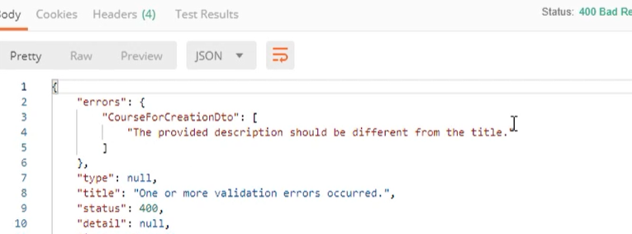

Works.

## Error messages

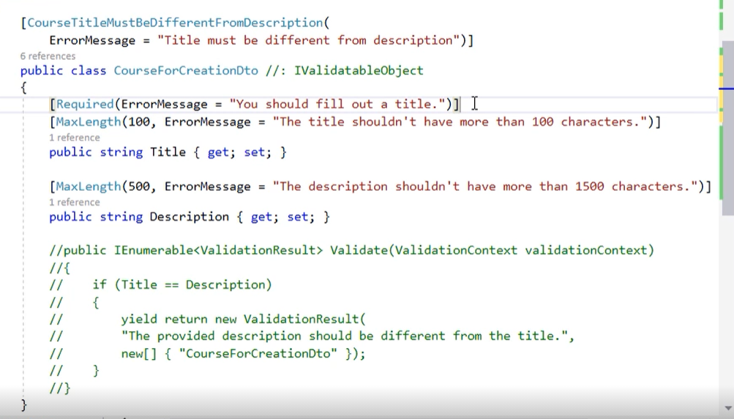

Set your own error message in attribute property ErrorMessage.

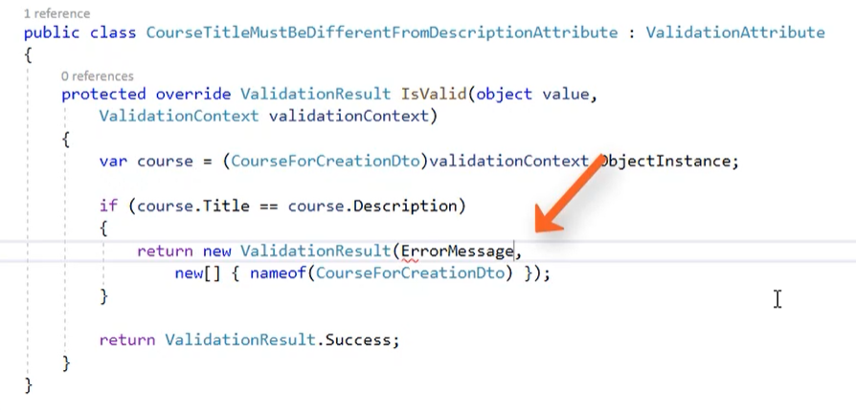

In validation attribute set a message from string to ErrorMessage property.

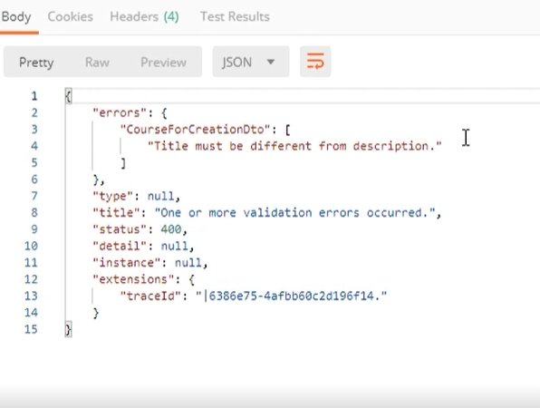

Working in the same way.

# Update Resources

## Description

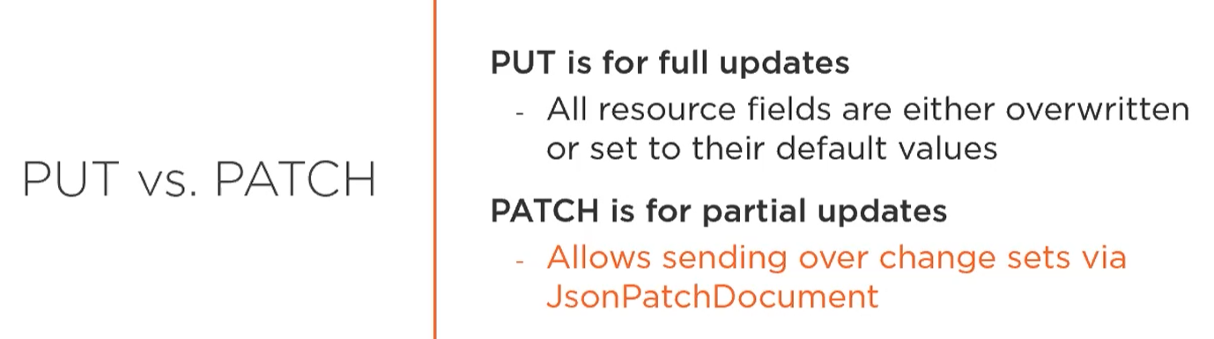

## Update Resource

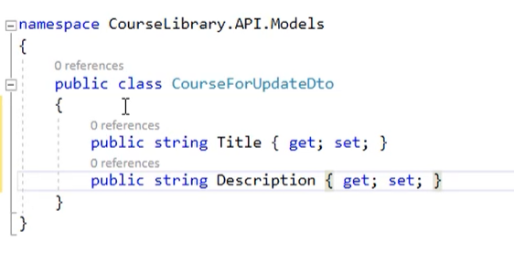

Create dto class with specific data.

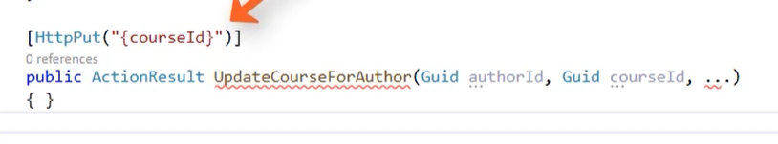

Do you see any ids in class. Great answer is no because there is no need to add ids in dto because course id and author id is a part of our path.

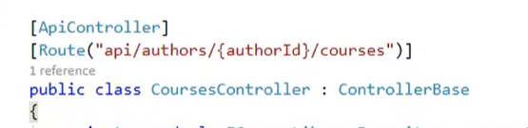

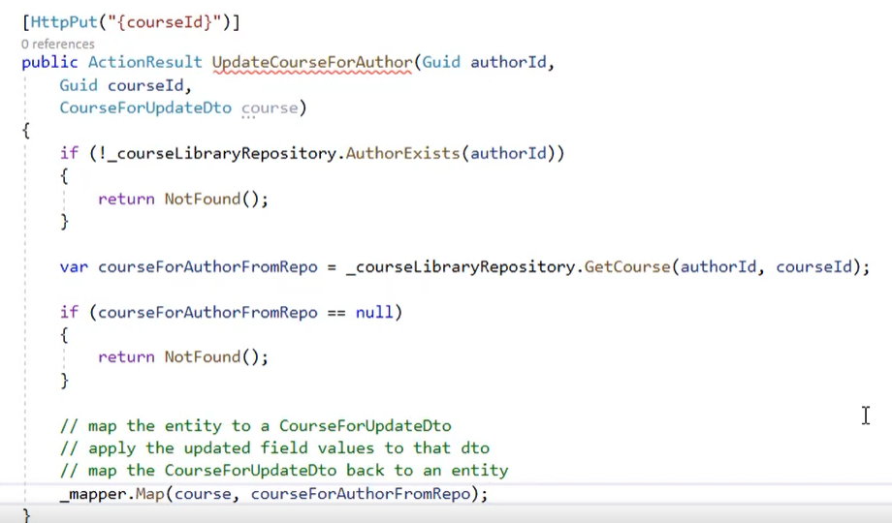

Now implement a action in controller.

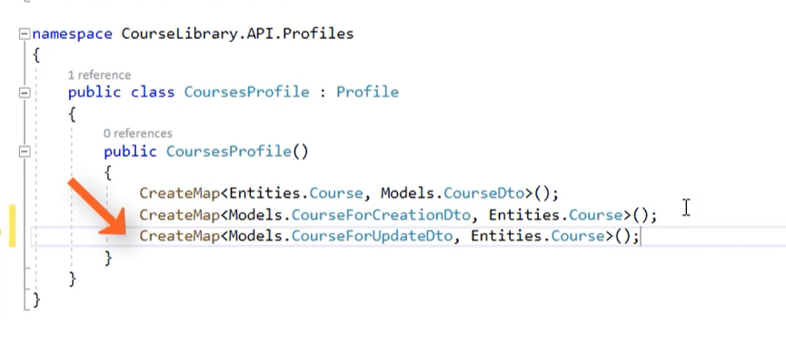

Add AM.

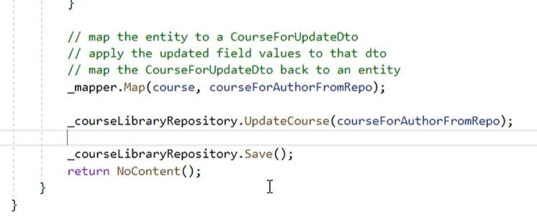

Return a value

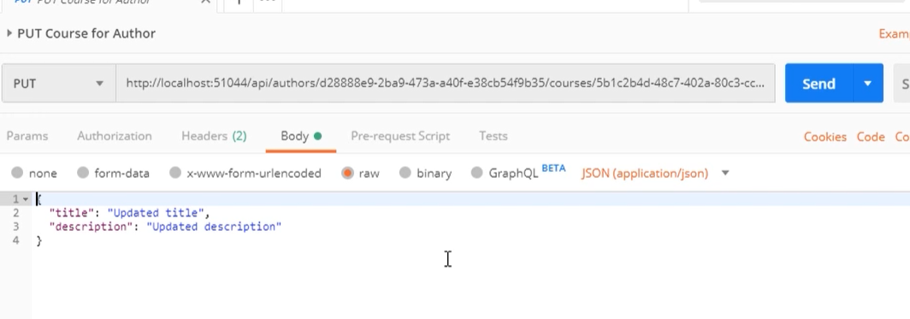

So aim and fire.

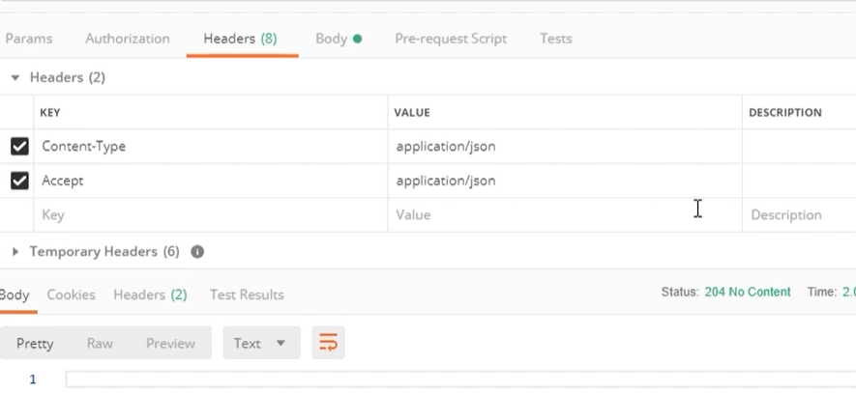

Add header and invoke. Everything works.

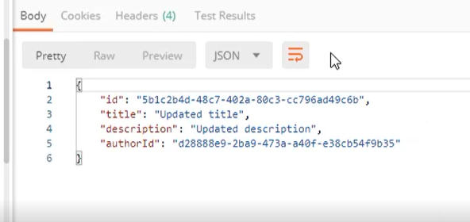

## Input Validation

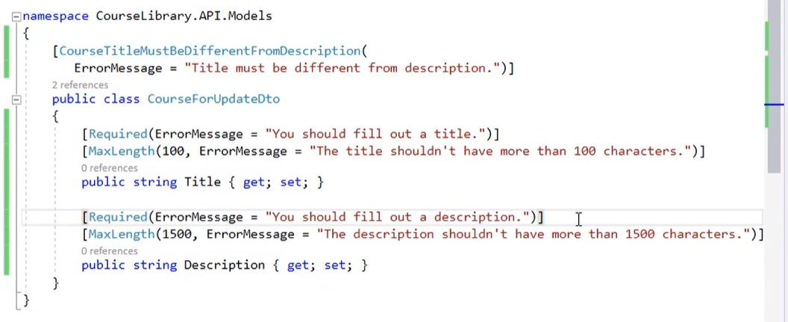

But now we have a lot duplication in validation so add a new abstract class and inherit all properties to dtos.

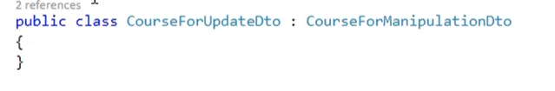

Now it looks like above (both dto for update and creation);

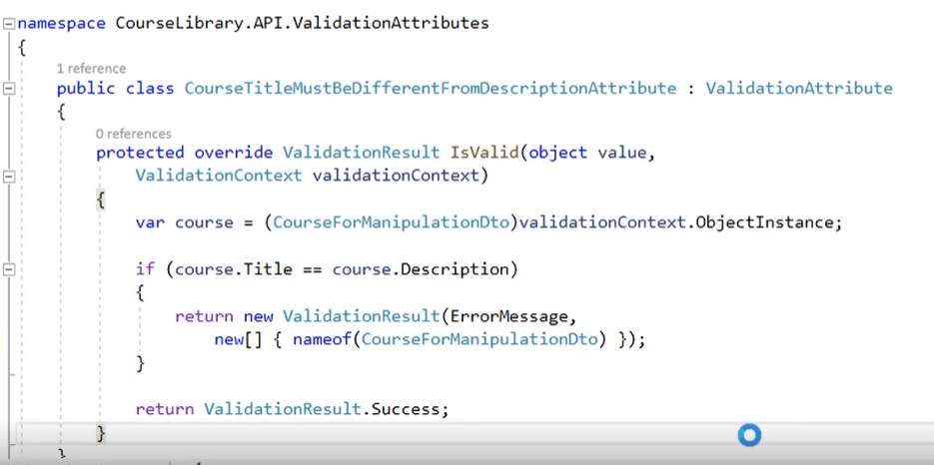

In attribute validation change class for CourseManipulationDto.

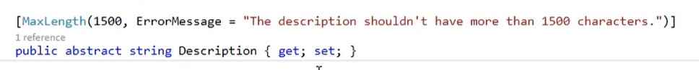

If you add abstract property to class you need to implement and override.

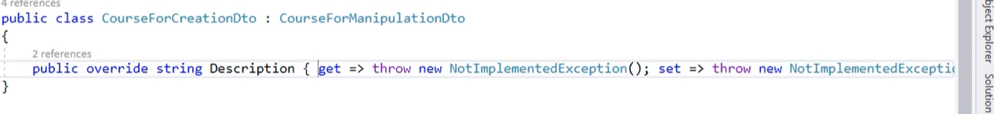

And change the validation rules.

If there will be a virtual it have a default implementation.

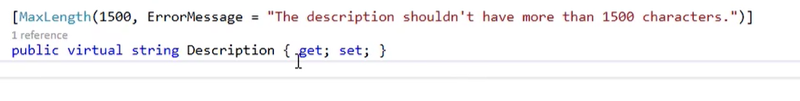

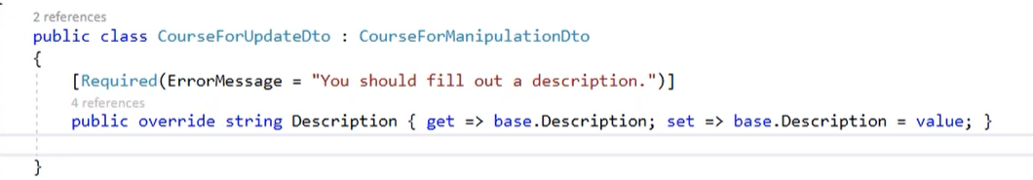

So create default implantation and add different validation attribute.

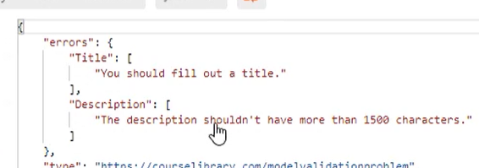

Works.

## Update Collection of Objects

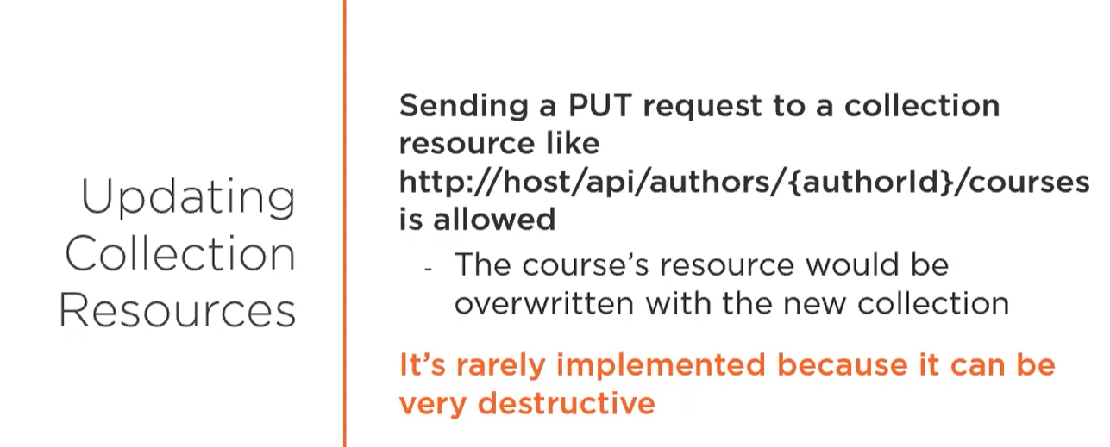

Don’t do this!!!

## Upserting

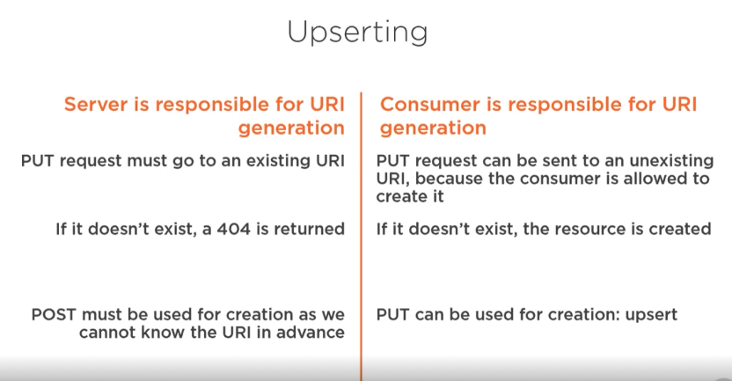

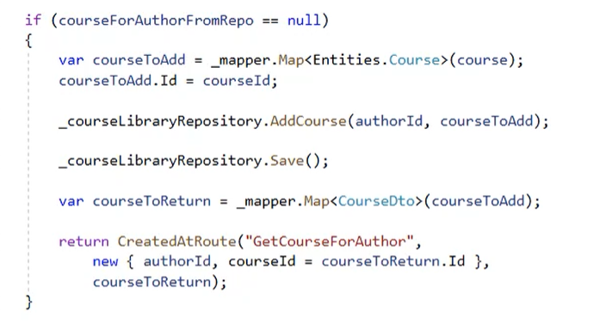

When object doesn’t exists add code which insert new one to db.

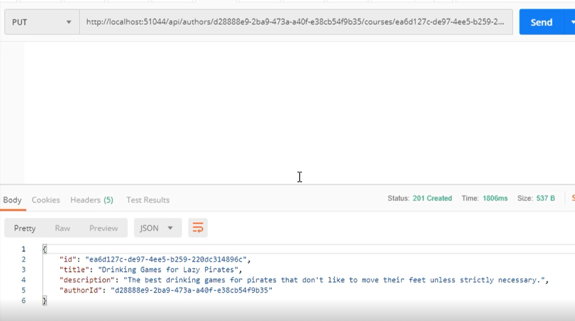

And when put request with not existed yet object will be send. An object will be added.

## Partial Update Patch

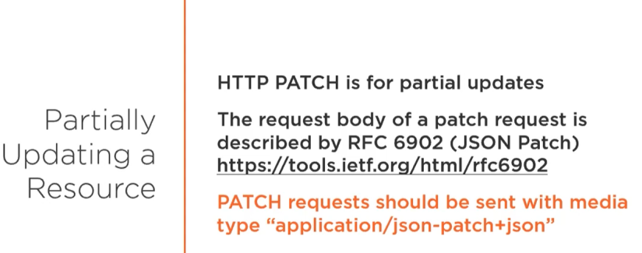

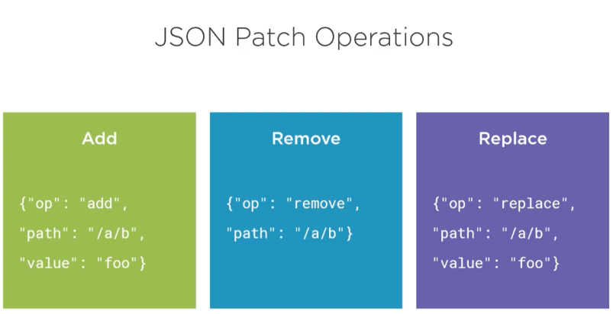

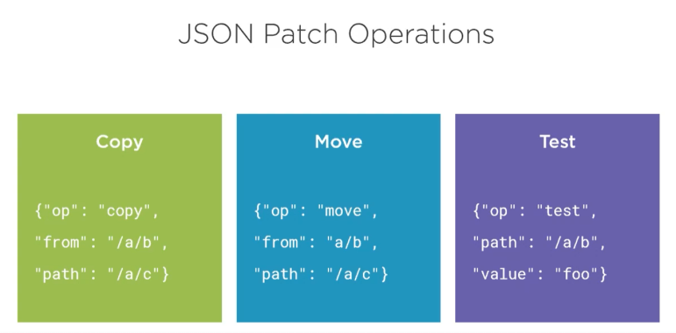 Test- check that value is equal

## Use Patch

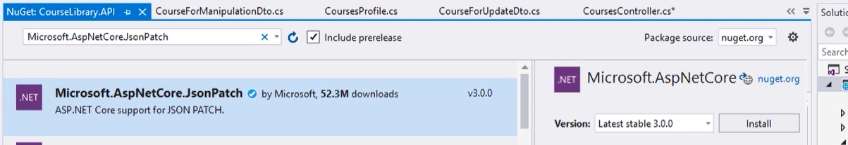

Install package

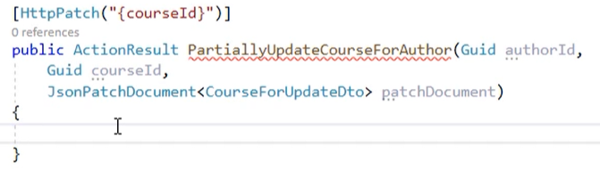’Add as param to method.

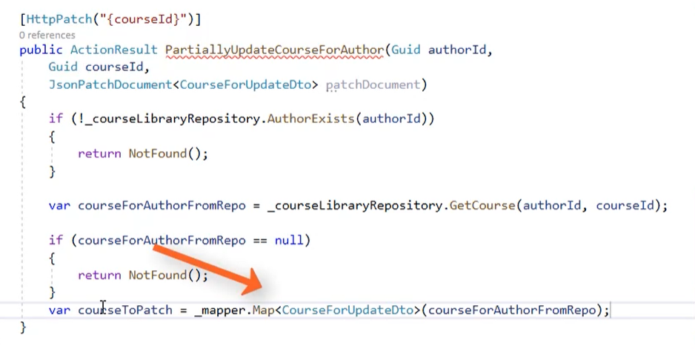

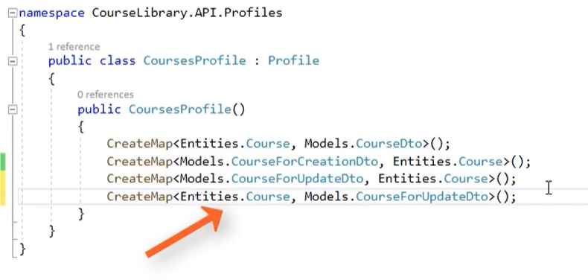

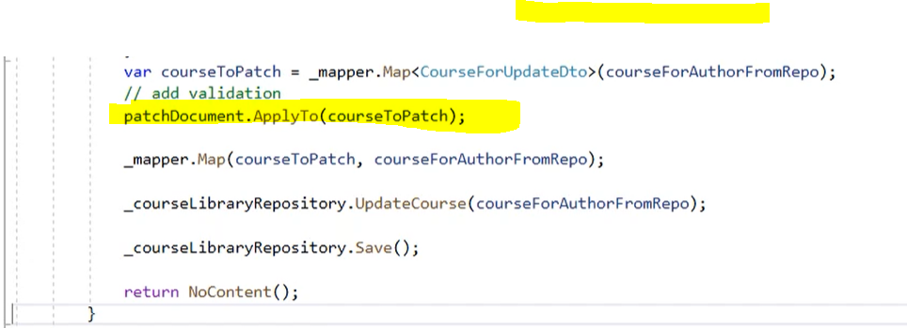

One different between update and patch is a patch document object with apply to method.

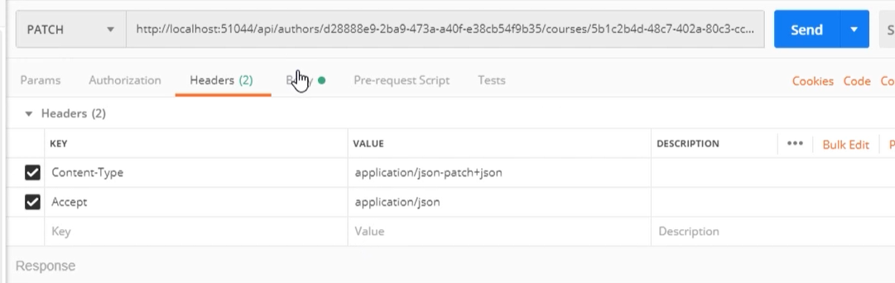

Request setup look on content type there is patch +json (it is required to patch action);

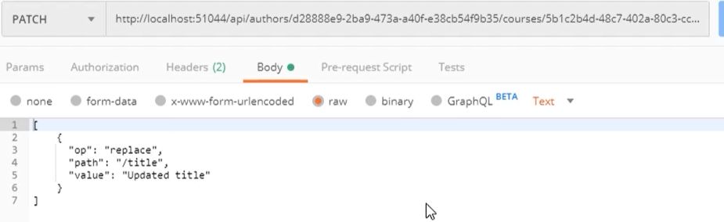

Body with replace operation

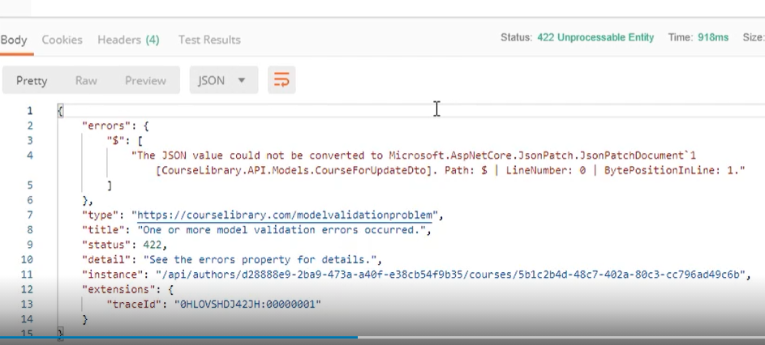

If there is a error please change library for newtonsofJson

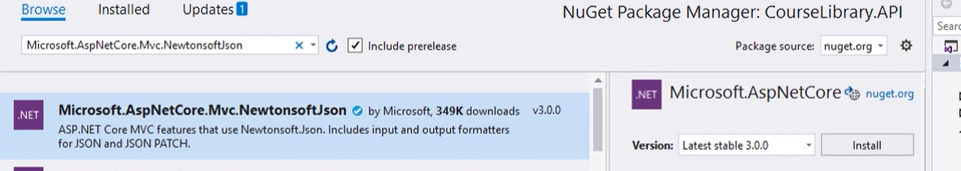Install

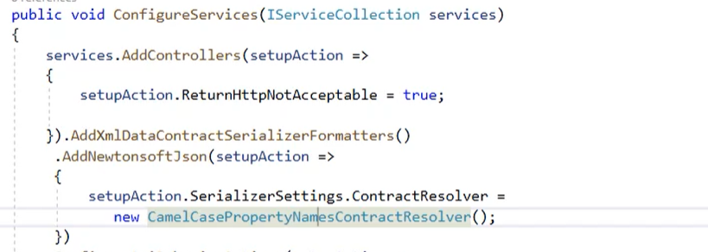

Register in startup.

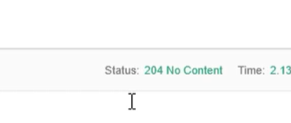

Works.

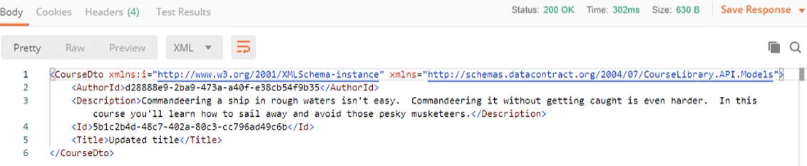

Updated.

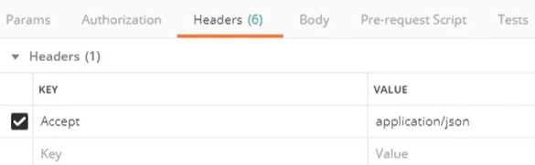

If there is a xml change header to json.

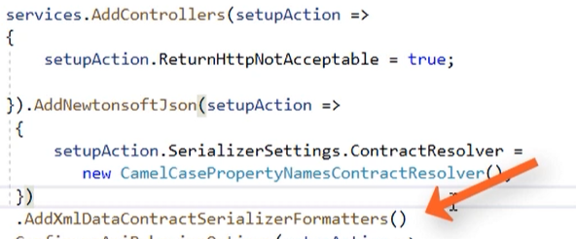

Or change an order. Json first.

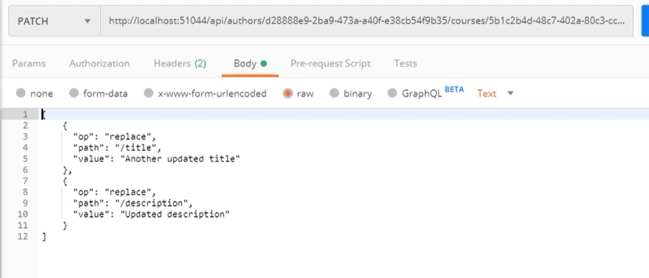

Patch can have many operation in body.

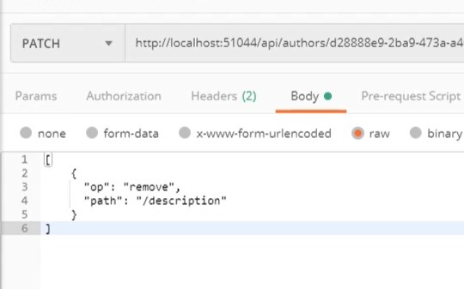

And of course it can be different not only replace. Look on 6 types.

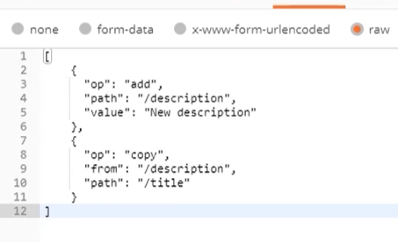

## Validate Patch

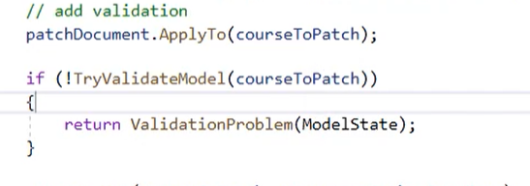

In patch dev needs to check that model is valid after applyTo method.

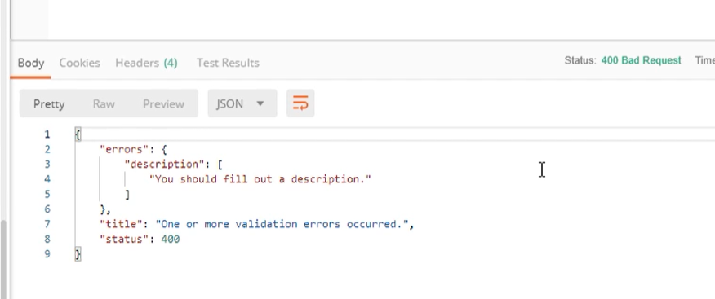

It works.

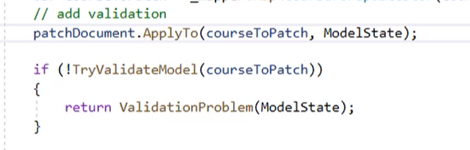

If there will be an error then pass ModelState to patch object.

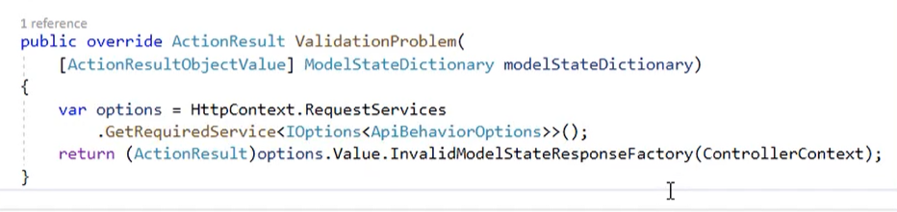

Validate problem can be override and get a standard properties.

## Upserting with Patch

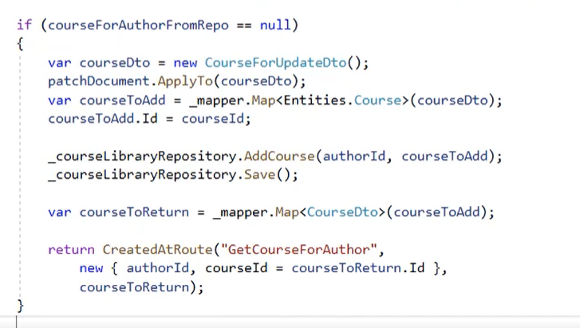

Add to patch method code to make upserting.

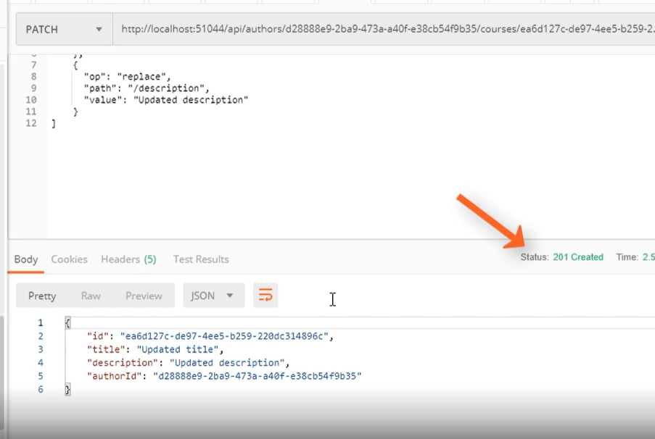

Hell Yeah

## Validate Input in Patch

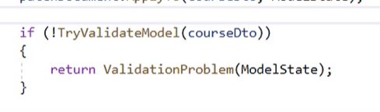

Add try valid in upserting code It works in the same way like in patch updating.

# Delete Resources

## Make an Action

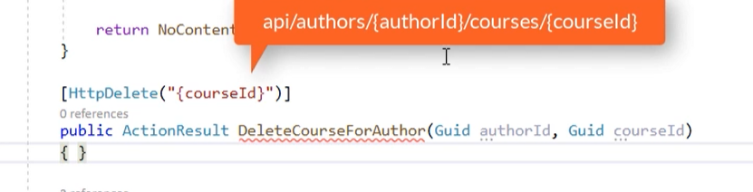

Path is the same like update or get single.

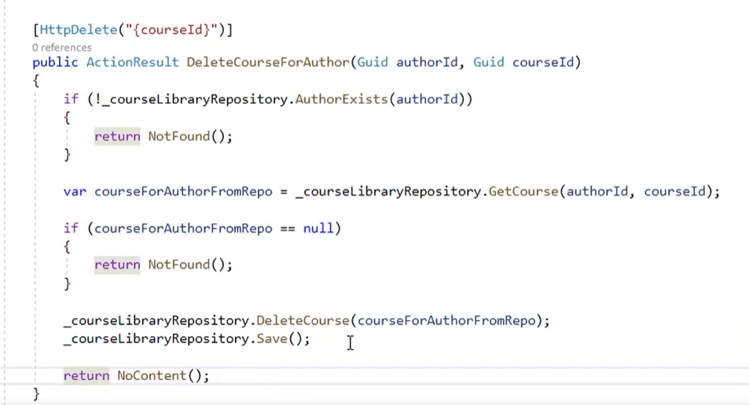

Implementation

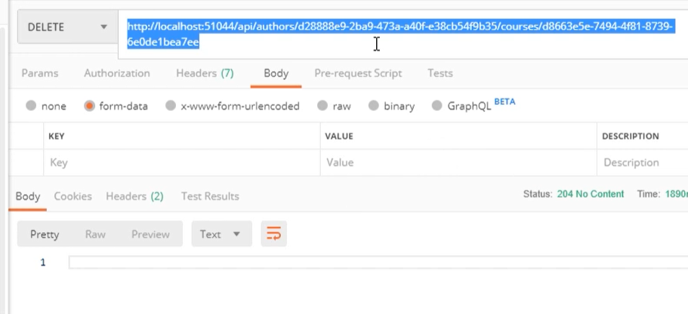

Deleted.

## Delete Parent and Children

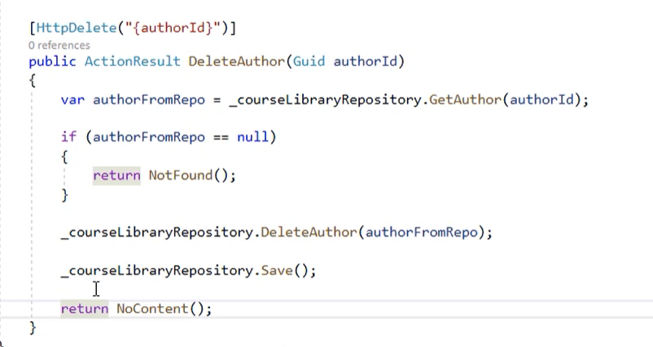

It will be cascade deletion abject with associated will be removed.

## Delete Collection

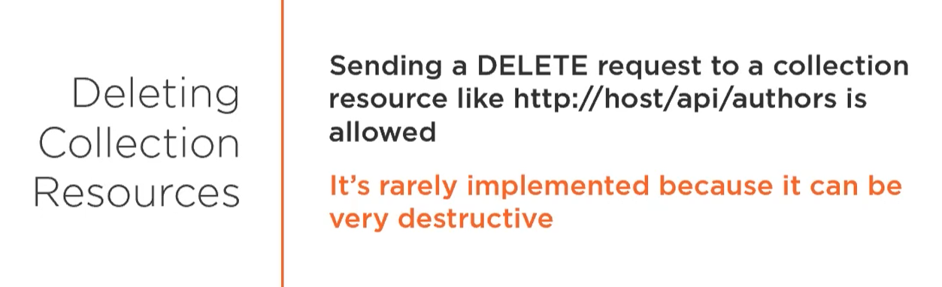

Don’t do this!!!

# Http methods reminder

